

**Arab Academy for Science, Technology, and Maritime Transport College of Computing and Information Technology – Cairo Computer Science & Software Engineering**

**B.Sc. Final Year Project**

**Adaptive Collision Avoidance System for High-Speed Driving**

|  |  |
| --- | --- |
| Presented By: |  |
| *Hassan Walid* | *Rawan Emad* |
| *211006778* | *211005553* |
| *Sandy Gamal*  *211006555* | *John Mamdouh*  *211014511* |
| *Ammar Mesbah 211006594* |  |
| Supervised By: |  |
| *Dr. Mostafa Abdelazzim* |  |
| January – 2025 |  |

# DECLARATION

I hereby certify that this material, which I now submit for assessment on the program of study leading to the award of Bachelor of Science in Computing and information technology is entirely my own work, that I have exercised reasonable care to ensure that the work is original, and does not to the best of my knowledge breach any law of copyright, and has not been taken from the work of others save and to the extent that such work has been cited and acknowledged within the text of my work.

|  |  |
| --- | --- |
| **Student Name: Hassan Walid Registration No.:211006778 Signed: Date:** 1/ 1/ 2025. | **Student Name: Rawan Emad Registration No.: 211005553 Signed: Date:** 1/ 1/ 2025. |
| **Student Name: Sandy Gamal Registration No.:211006555 Signed: Date:** 1/ 1/ 2025. | **Student Name: John Mamdouh Registration No.:** **211014511 Signed: Date:** 1/ 1/ 2025. |
| **Student Name: Ammar Mesbah Registration No.:** **211006594 Signed: Date:** 1/ 1/ 2025. |  |

# ACKNOWLEDGEMENT

“We would like to express our deep gratitude to the Arab Academy for Science and Technology for their support and guidance throughout this project. Their invaluable contribution has been a key factor in the success of our work.

We are also extremely grateful to our supervisor, Dr.Mostafa Abdelazim, for his valuable insights and guidance. Their expertise and support have been invaluable to us, and we are deeply thankful for their ongoing support and encouragement.

Finally, we would like to express our gratitude to our country and government for providing the resources and support necessary to complete this project. We are proud to be able to contribute to the development and advancement of our nation through our work.”

Abstract

This report introduces the design and development of an Adaptive Collision Avoidance System for high-speed driving, addressing the critical need for enhanced vehicular safety. The proposed system combines cutting-edge proximity sensors, smart radar technology, and advanced traffic prediction algorithms to mitigate collision risks while ensuring adherence to speed regulations. By continuously monitoring the distance between vehicles and dynamically adjusting the speed, the system provides a proactive approach to preventing accidents.

Key features of the system include proximity-based collision prevention and radar speed compliance. Ultrasonic and radar sensors enable real-time detection of surrounding objects, while smart radar technology ensures 360-degree coverage, even under adverse weather conditions. If an unsafe proximity is detected, the system issues visual and auditory alerts, and in the absence of corrective driver actions, automatically adjusts the vehicle’s speed proportionally to the risk level. The radar speed compliance feature further enhances safety by detecting speed limits enforced by radar systems and dynamically regulating the vehicle’s speed accordingly.

Additionally, the system leverages AI-powered traffic prediction to analyze real-time traffic patterns and anticipate congestion. This innovative integration ensures smooth driving behavior and improved decision-making under varying traffic conditions. By surpassing the limitations of existing collision avoidance technologies, this system offers a transformative solution aimed at significantly reducing rear-end collisions and enhancing road safety for drivers and passengers alike. The report details the problem statement, system architecture, technological tools, and expected outcomes, providing a comprehensive overview of the project and its potential impact.

Table of Contents

1. Introduction 5
   1. Introduction 5
   2. Project Purpose 5
   3. Intended Audience 6
   4. Intended Use 7
   5. Motivation 8
   6. Problem Statement 12
   7. Scope 13
   8. Objectives 14
   9. Challenges 15
      1. Technical Challenges 15
      2. Ethical Challenges 16
      3. Resource-Related Challenges 17
   10. Risks 18
   11. Standards 19
   12. Constraints 21
   13. Summary 22
2. Market Analysis and Related Work 23
   1. Introduction 23
   2. Market Analysis 24
      1. SWOT Analysis 24
      2. The 7 P’s 25
      3. PESTEL Analysis 26
      4. Similar Projects 27
   3. Background 34
   4. Literature Review 43
   5. Summary 48
3. Methodology and System Analysis 49
   1. Introduction 49
   2. Methodology 50
      1. Agile Sprints 52
      2. Proof of Interest 53
   3. System Analysis 59
      1. Functional Requirements 59
      2. Detailed Functional Requirements 60
      3. System Requirements 61
      4. User Requirements 61
      5. Non – Functional Requirements 62
   4. System Design 64
      1. Proposed Model 64
      2. Features 66
      3. Class Diagram 67
      4. Use Cases 73
      5. Sequence Diagrams 78
      6. Architectural Design 84
   5. Summary 86
4. Implementation 87
   1. Introduction 87
   2. Data Sets 88
   3. Development Environment 89
   4. Application Prototype 92
   5. Conclusion 93
5. Conclusion and Future Work 94
   1. Conclusion 94
   2. Future Work 95

### Table of Figures

Figure 1-1 Motivation Statistics “Egypt” 9

Figure 1-2 Motivation Statistics “Egypt” 9

Figure 1-3 Motivation Statistics “Global” 10

Figure 1-4 Motivation Statistics “US Market" 11

Figure 1-5 Motivation Statistics Pie Chart “US Market” 11

Figure 1-6 Motivation Statistics “Global Market” 11

Figure 2-1 - SWOT Analysis 24

Figure 2-2 - PESTEL Analysis 26

Figure 2-3 - CNN Model 34

Figure 2-4 RNN Model 35

Figure 2-5 Bayesian Model 36

Figure 2-6 Deep Neural Network 37

Figure 2-7 Random Forest 38

Figure 2-8 Support Vector Machine 39

Figure 2-9 Decision Tree 40

Figure 2-10 XGBoost 41

Figure 3-1 Questionnaire Response 53

Figure 3-2 Questionnaire Response 54

Figure 3-3 Questionnaire Response 54

Figure 3-4 Questionnaire Response 55

Figure 3-5 Questionnaire Response 55

Figure 3-6 Questionnaire Response 56

Figure 3-7 Questionnaire Response 56

Figure 3-8 Questionnaire Response 57

Figure 3-9 Questionnaire Response 57

Figure 3-10 Questionnaire Response 58

Figure 3-11 - Proposed Model 64

Figure 3-12 Class Diagram 67

Figure 3-13 Use case Diagram 73

Figure 3-14 General Sequence Diagram 78

Figure 3-15 Registration Sequence Diagram 79

Figure 3-16 Login Sequence Diagram 80

Figure 3-17 Pairing Device Sequence Diagram 81

Figure 3-18 Real time analysis and Chronic Disease Assessment Sequence Diagram 82

Figure 3-19 Real Time Analysis using the Wearable Device 83

Figure 3-20 Hardware Architecture Diagram 84

### List of Tables

Table 1- Risks and Mitigation 18

Table 2 - List of Standards 19

Table 3 - List of Constraints 21

Table 4 - 7 P's 25

Table 5 - Similar Projects Comparison 33

Table 6 Papers Comparison 46

Table 7 - Project Sprints 52

Table 8 Detailed Function Requirements 60

Table 9 Report Use case 74

Table 10 Recommendation Use Case 75

Table 11 Prescription Use Case 76

Table 12 Sending Data Use Case 77

*Chapter One*

## Introduction

#### Introduction

In the era of modern transportation, ensuring safety remains a paramount concern, particularly in high-speed driving conditions where reaction time is limited, and the margin for error is minimal. Road accidents caused by collisions are among the leading causes of fatalities and injuries worldwide, often resulting from drivers' inability to respond promptly to sudden changes in traffic dynamics.

The **Adaptive Collision Avoidance System for High-Speed Driving** is designed to address these challenges through the integration of advanced technologies, including proximity sensors, smart radar systems, and traffic prediction algorithms. This system continuously monitors the vehicle's surroundings, assesses potential risks, and delivers timely alerts to the driver. If the driver fails to take corrective action, the system autonomously adjusts the vehicle's speed proportionally to the level of danger, significantly reducing the risk of collisions.

What distinguishes this system from existing solutions is its innovative combination of features, such as 360-degree radar coverage, real-time traffic prediction, and dynamic speed adjustments based on vehicle proximity and external speed limits enforced by road radars. By merging these capabilities, the system not only enhances driver awareness but also actively intervenes to promote road safety.

This project aspires to advance automotive safety technologies by delivering a robust and intelligent solution tailored for high-speed scenarios. By doing so, it seeks to reduce accidents and foster safer driving experiences for all road users.

#### Project Purpose

The purpose of the **Adaptive Collision Avoidance System for High-Speed Driving** is to enhance road safety by addressing the limitations of existing collision prevention technologies. This project aims to reduce the risk of accidents through real-time monitoring, timely alerts, and autonomous speed adjustments. By leveraging AI-powered traffic prediction, the system ensures smoother traffic flow and better driver decision-making. Additionally, it promotes compliance with speed regulations by dynamically adjusting vehicle speed based on detected limits. With reliable performance under diverse conditions, including adverse weather, the project aspires to advance intelligent transportation systems and foster safer driving experiences.

#### Intended Audience

1. **Automotive Manufacturers and Engineers**

* Professionals developing vehicles who aim to incorporate advanced safety systems and technologies.
* Engineers specializing in smart sensor integration and autonomous vehicle design.

1. **Policymakers and Transportation Authorities**

* Officials focused on improving road safety standards and reducing traffic accident rates.
* Transportation authorities seeking innovative solutions to enforce speed regulations effectively.

1. **Technology Enthusiasts and Researchers**

* Researchers exploring AI and sensor-based systems in automotive safety.
* Technology innovators interested in developing intelligent transportation systems.

1. **Everyday** **Drivers**

* Drivers who will benefit from enhanced safety features, particularly in high-speed scenarios.
* Vehicle owners seeking reliable safety technologies for a better driving experience.

#### Intended Use

1. **Collision** **Prevention**
   * Real-time monitoring and detection of surrounding objects to prevent rear-end and side-impact collisions.
   * Automatic speed adjustment in response to unsafe proximities to mitigate collision risks.
2. **Driver Assistance**
   * Provision of visual and auditory alerts to inform drivers of potential hazards.
   * Autonomous intervention when drivers fail to respond to critical situations.
3. **Traffic Regulation Compliance**
   * Dynamic speed adjustments to adhere to detected speed limits enforced by road radars.
   * Assistance in maintaining lawful driving behavior through proactive speed regulation.
4. **Traffic Flow Optimization**
   * Prediction and analysis of real-time traffic patterns to prevent congestion.
   * Improved driving decisions through AI-powered traffic insights.
5. **Adaptation to Adverse Conditions**
   * Reliable functionality in various weather conditions using smart radar systems.
   * Enhanced safety through 360-degree coverage and robust sensor technology.

#### Motivation

Road safety is a significant challenge in Egypt, with traffic accidents being a major cause of fatalities and injuries. According to official statistics, in 2021 alone, Egypt recorded 7,101 road fatalities, marking a concerning 15.2% increase compared to the previous year. While 2023 saw some improvement with a 24.5% decrease in road fatalities to 6,916, the overall safety situation remains alarming. The same year experienced a sharp 27% increase in road accident injuries, rising from 55,991 in 2022 to 71,016 in 2023. These figures underscore the critical need for innovative and effective solutions to address the growing safety concerns, particularly in high-speed driving scenarios where reaction times are minimal.

High-speed driving poses a unique set of risks, as drivers often have limited time to respond to sudden changes in traffic conditions. Many accidents are caused by human error, such as delayed responses or failure to maintain safe distances between vehicles. Existing collision avoidance systems lack the adaptability required for dynamic environments, especially in adverse weather conditions or congested traffic.

The Adaptive Collision Avoidance System for High-Speed Driving is motivated by the urgent need to address these challenges and reduce the burden of traffic accidents in Egypt. By leveraging cutting-edge technologies such as proximity sensors, smart radar systems, and AI-powered traffic prediction, the project seeks to create a proactive and intelligent safety solution. The integration of these technologies not only enhances driver awareness but also actively intervenes when necessary, significantly reducing the likelihood of collisions.

This project also aligns with Egypt's national efforts to improve road safety standards and reduce the socioeconomic impact of traffic accidents. As the country invests in modernizing its infrastructure and transportation systems, innovations like this one can play a pivotal role in fostering safer roads and saving lives. Beyond its local impact, the project has the potential to contribute to global advancements in intelligent transportation systems, making driving safer and more efficient for everyone.

*Fig 1 Fig 2*

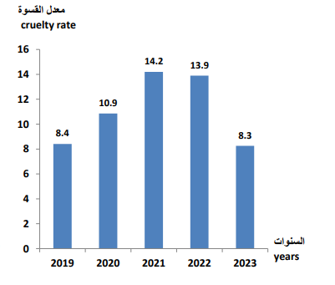 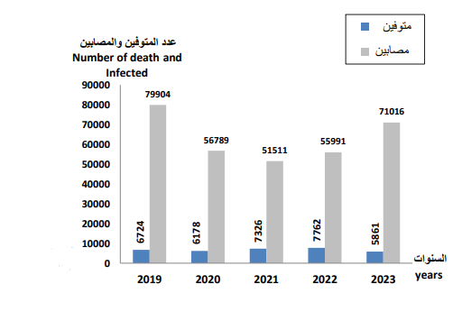

#### Problem Statement

Road safety is a critical global issue, and in Egypt, it is particularly pressing due to the high incidence of traffic accidents, which rank among the leading causes of fatalities and injuries. According to recent data, thousands of lives are lost annually on Egyptian roads, with tens of thousands more suffering serious injuries. Many of these accidents occur in high-speed driving scenarios where reaction times are limited, and the margin for error is extremely narrow. These conditions make it challenging for drivers to respond promptly to sudden changes in traffic dynamics, such as abrupt braking, lane changes, or the presence of unexpected obstacles.

Human error plays a significant role in traffic accidents, with delayed reaction times, poor judgment, and failure to maintain safe following distances being common contributors. Additionally, external factors like adverse weather conditions, poor visibility, and inadequate traffic management exacerbate the risks associated with high-speed driving. Despite the availability of existing collision avoidance systems, these technologies are often insufficient in addressing the complexities of dynamic driving environments. For instance, many current systems lack 360-degree coverage, struggle with accurate detection in bad weather, and do not incorporate real-time traffic prediction or compliance with external speed regulations enforced by radar systems.

Furthermore, the absence of predictive capabilities in most collision avoidance systems limits their effectiveness in preventing accidents caused by traffic congestion or erratic driver behavior. While some solutions provide basic alerts, they rely heavily on the driver’s ability to respond promptly, which is not always feasible in high-speed scenarios. In cases where drivers fail to act, the lack of automated intervention can lead to catastrophic outcomes.

The socio-economic impact of road accidents in Egypt is profound, affecting individuals, families, and the nation as a whole. Beyond the loss of life and physical injuries, traffic accidents impose significant financial burdens due to medical expenses, vehicle damage, and productivity loss. This underscores the urgent need for a transformative approach to collision avoidance, one that goes beyond traditional technologies and addresses the root causes of traffic accidents in a proactive and comprehensive manner.

The **Adaptive Collision Avoidance System for High-Speed Driving** is designed to tackle these challenges by integrating advanced proximity sensors, smart radar systems, and AI-driven traffic prediction algorithms. Unlike existing solutions, this system offers real-time monitoring, 360-degree coverage, and autonomous intervention when necessary. By dynamically adjusting vehicle speed based on proximity, traffic conditions, and external speed regulations, the system significantly reduces the likelihood of collisions and enhances overall road safety.

This project seeks to fill the gaps in current safety technologies, providing a robust, intelligent solution tailored to the unique demands of high-speed driving. Its implementation has the potential to save lives, reduce injuries, and alleviate the socio-economic burden of road accidents in Egypt and beyond.

#### Scope

The **Adaptive Collision Avoidance System for High-Speed Driving** is a comprehensive safety solution designed to address the challenges of high-speed driving and enhance road safety. Its scope encompasses the following key areas:

1. **Collision Detection and Prevention**
   * Implementation of proximity sensors and smart radar systems to detect surrounding vehicles and obstacles in real-time.
   * Provision of visual and auditory alerts to warn drivers of potential hazards.
   * Autonomous intervention to adjust vehicle speed proportionally to the detected risk levels when drivers fail to take corrective action.
2. **AI-Powered Traffic Prediction**
   * Analysis of real-time traffic patterns using AI algorithms to anticipate potential congestion and hazards.
   * Support for smoother traffic flow and informed driving decisions based on predictive insights.
3. **Dynamic Speed Regulation**
   * Detection of speed limits enforced by external radar systems.
   * Automatic speed adjustment to ensure compliance with legal and safety regulations.
4. **Scalability and Flexibility**
   * Adaptability for use in different vehicle types, ranging from personal cars to commercial vehicles.
   * Potential for future expansion to include integration with autonomous driving systems.
5. **Enhanced Driver Experience**
   * User-friendly interface for seamless interaction and intuitive feedback.
   * Reduced stress and increased confidence for drivers, particularly in high-speed and high-risk situations.
6. **Targeted Deployment and Testing**
   * Initial focus on high-speed driving scenarios and highways where the risk of collisions is highest.
   * Testing under diverse conditions, including varying traffic densities and weather challenges, to ensure system reliability.

#### Objectives

* Design and implement a reliable system that utilizes proximity sensors and radar technology to detect potential collisions in real-time and provide timely alerts to enhance situational awareness.
* Develop an automated mechanism to intervene and adjust vehicle speed when drivers fail to respond to critical alerts, mitigating collision risks.
* Achieve 360-degree monitoring of the vehicle’s surroundings using advanced radar systems, ensuring accurate detection of obstacles and other vehicles even in adverse weather conditions.
* Integrate AI algorithms to analyze real-time traffic data, anticipate potential congestion or risky scenarios, and enable proactive adaptation to changing traffic conditions for improved safety and efficiency.
* Develop a speed compliance module that detects external speed limits enforced by road radar systems and automatically adjusts the vehicle's speed to adhere to legal and safety standards.
* Ensure the system is scalable and adaptable for deployment across different vehicle types, including passenger cars and commercial vehicles, with potential for future enhancements such as V2V (Vehicle-to-Vehicle) and V2I (Vehicle-to-Infrastructure) communication.
* Test and validate the system's performance under diverse environmental and traffic conditions, optimizing sensor calibration and data processing for maximum accuracy and responsiveness.
* Develop an intuitive user interface that clearly communicates system alerts and actions, reducing driver stress and providing consistent safety support in high-risk scenarios.
* Contribute to reducing rear-end and side-impact collisions, particularly in high-speed environments, and decreasing the severity of accidents through timely intervention.
* Lay the groundwork for integration with broader intelligent transportation systems, supporting smart highways, automated traffic management, and enhanced road network efficiency.
* Reduce the financial and socio-economic impact of traffic accidents by preventing vehicle damage, medical expenses, and productivity loss while improving public confidence in intelligent safety technologies.
* Showcase the potential of combining AI, sensor technology, and radar systems to push the boundaries of collision avoidance systems and offer a state-of-the-art solution for high-speed driving.

#### Challenges

##### Technical Challenges

1. **Sensor Accuracy and Calibration**
   * Ensuring the accuracy and reliability of proximity sensors and radar systems in detecting objects under diverse conditions, including adverse weather and varying traffic densities.
2. **Real-Time Data Processing**
   * Developing algorithms capable of processing large volumes of sensor and traffic data in real-time without latency to enable timely decision-making.
3. **Integration of AI Models**
   * Training and deploying AI algorithms that can accurately predict traffic patterns and hazards while ensuring low computational overhead for real-time operation.
4. **Environmental Variability**
   * Adapting the system to function consistently across diverse environments, including urban, rural, and high-speed highway scenarios, as well as in poor visibility conditions like fog or heavy rain.
5. **Dynamic Speed Adjustment**
   * Designing mechanisms to seamlessly adjust vehicle speed in response to detected risks without causing abrupt or unsafe changes in driving behavior.
6. **System Scalability**
   * Creating a modular system architecture that can be scaled and customized for different vehicle types and varying levels of automation.
7. **Hardware and Software Integration**
   * Ensuring smooth integration between hardware components (sensors, radar systems) and software modules (AI models, control systems) for seamless operation.
8. **Energy Efficiency**
   * Minimizing the energy consumption of the system to ensure it does not significantly impact the vehicle’s overall power efficiency.
9. **Robust Communication**
   * Establishing reliable communication channels between system components, including internal subsystems and external infrastructure like road radar systems.
10. **Cost-Effectiveness**
    * Balancing the use of advanced technologies with cost considerations to ensure the system remains affordable and accessible for widespread adoption.
11. **System Validation and Testing**
    * Developing rigorous testing protocols to validate the system’s performance under simulated and real-world conditions, addressing edge cases and potential failures.
12. **Compliance with Regulations**
    * Ensuring the system adheres to global and local automotive safety standards and regulations, including data privacy laws for AI and sensor data usage.
      1. Ethical Challenges
13. **Driver Autonomy vs. System Intervention**
    * Balancing the system’s ability to intervene in critical situations with the driver’s autonomy to maintain trust and prevent over-reliance on automation.
14. **Data Privacy and Security**
    * Ensuring the protection of sensitive data collected by the system, including real-time traffic patterns and vehicle usage, from unauthorized access or misuse.
15. **Bias in AI Algorithms**
    * Addressing potential biases in AI models that could impact decision-making, such as prioritizing certain types of vehicles or scenarios over others.
16. **Accountability for System Failures**
    * Determining liability in cases where the system fails to prevent an accident, including clear guidelines for manufacturer, developer, or user responsibility.
17. **Impact on Driving Behavior**
    * Preventing drivers from becoming overly dependent on the system, which could lead to complacency or reduced driving skills over time.
18. **Accessibility and Equity**
    * Ensuring the system is designed and priced to be accessible to a wide range of users, avoiding disparities in safety technologies between socio-economic groups.
19. **Ethical Decision-Making in Emergencies**
    * Programming the system to make ethical decisions during unavoidable accidents, such as choosing between multiple potential impacts.
20. **Transparency in System Operations**
    * Providing users with clear information about how the system works, its limitations, and the nature of interventions it may perform.
21. **Job Displacement Concerns**
    * Addressing fears related to the impact of advanced safety systems on jobs in driving-related industries, such as trucking and delivery services.
22. **Global Standardization**
    * Navigating ethical differences and regulatory standards across regions to ensure the system aligns with varying cultural and legal expectations.

##### Resource-Related Challenges

1. **Cost of Advanced Sensors and Technology**
   * Managing the high costs of proximity sensors, radar systems, and AI integration to ensure the system is affordable for mass-market deployment.
2. **Hardware Availability**
   * Securing reliable access to high-quality sensors, radar components, and processors, particularly in regions with limited technological infrastructure.
3. **Skilled Workforce**
   * Recruiting and retaining skilled professionals, including engineers and AI specialists, to design, implement, and maintain the system.
4. **Infrastructure Constraints**
   * Addressing limitations in existing road infrastructure, such as inconsistent signage, poorly maintained roads, or lack of external radar systems in certain regions.
5. **Energy Requirements**
   * Ensuring that the system operates efficiently without significantly increasing the vehicle’s energy consumption or reducing its range in electric vehicles.
6. **Testing Facilities**
   * Gaining access to sophisticated testing environments, such as simulation platforms and real-world test tracks, to validate the system’s functionality and reliability.
7. **Development Time and Budget**
   * Balancing the need for thorough research, design, and testing with constraints on time and funding during project development.
8. **Integration of Emerging Technologies**
   * Allocating resources for incorporating cutting-edge advancements, such as 5G connectivity and improved AI models, while managing associated costs and timelines.
9. **Global Supply Chain Dependencies**
   * Mitigating risks associated with supply chain disruptions, which could impact the availability of essential components.
10. **Stakeholder Collaboration**
    * Ensuring effective collaboration among stakeholders, including manufacturers, technology providers, and regulatory bodies, to align resources and objectives.

#### Risks

*Table 1- Risks and Mitigation*

|  |  |  |  |  |  |  |
| --- | --- | --- | --- | --- | --- | --- |
| **REF/ID** | **RISK TYPE** | **RISK DESCRIPTION** | **RISK SEVERITY** | **RISK LIKELIHOOD** | **IMPACT** | **MITIGATIONS / WARNINGS / REMEDIES** |
| 1 | Technical | |  | | --- | | Sensors may fail to detect obstacles accurately in adverse weather conditions (e.g., fog, rain). |  |  | | --- | |  | | **UNDESIRABLE** | **PROBABLE** | **EXTREME** | |  | | --- | | Implement advanced sensor calibration and redundancy, such as combining ultrasonic and radar systems for enhanced reliability. |  |  | | --- | |  | |
| 2` | Technical | |  | | --- | | AI algorithms might exhibit bias in detecting or prioritizing certain objects or scenarios. |  |  | | --- | |  | | **TOLERABLE** | **POSSIBLE** | **MEDIUM** | |  | | --- | | Conduct extensive testing and validation with diverse datasets to eliminate biases and improve algorithm robustness. |  |  | | --- | |  | |
| 3 | Technical | |  | | --- | | Delays in real-time data processing may hinder timely decision-making in critical scenarios. |  |  | | --- | |  | | **UNDESIRABLE** | **PROBABLE** | **HIGH** | |  | | --- | | Optimize algorithms for real-time performance and use high-speed processors for efficient computation. |  |  | | --- | |  | |
| 4 | Hardware | |  | | --- | | Critical hardware components such as sensors or processors may fail unexpectedly. |  |  | | --- | |  | | **INTOLERABLE** | **POSSIBLE** | **EXTREME** | |  | | --- | | Implement fault detection systems and redundancy for key hardware components. |  |  | | --- | |  | |
| 5 | Hardware | |  | | --- | | Unauthorized access to the system could result in data breaches or malicious control over vehicle functions. |  |  | | --- | |  | | **UNDESIRABLE** | **PROBABLE** | **EXTREME** | |  | | --- | | Use robust encryption protocols, regular security updates, and intrusion detection systems to protect against cyber threats. |  |  | | --- | |  | |
| 6 | Development | |  | | --- | | Challenges in integrating the system with existing vehicle platforms or infrastructure could delay deployment. |  |  | | --- | |  | | **TOLERABLE** | **POSSIBLE** | **MEDIUM** | |  | | --- | | Design modular and flexible integration frameworks and collaborate with OEMs for compatibility testing. |  |  | | --- | |  | |
| 7 | Development | |  | | --- | | High development and production costs may make the system unaffordable for mass-market users. |  |  | | --- | |  | | **TOLERABLE** | **PROBABLE** | **HIGH** | |  | | --- | | Focus on cost optimization during design and development, and explore partnerships to subsidize costs. |  |  | | --- | |  | |
| 8 | Delay | |  | | --- | | The system might not fully comply with local or global automotive safety standards and regulations. |  |  | | --- | |  | | **INTOLERABLE** | **POSSIBLE** | **HIGH** | |  | | --- | | Conduct thorough reviews of regulatory requirements and engage with policymakers early in the development process. |  |  | | --- | |  | |
| 9 | Delay | |  | | --- | | The system might perform inconsistently across different road environments, such as rural areas with unmarked roads. |  |  | | --- | |  | | **TOLERABLE** | **PROBABLE** | **MEDIUM** | |  | | --- | | Conduct field testing in diverse environments and enhance AI models to adapt to varying conditions. |  |  | | --- | |  | |
| 10 | Delay | |  | | --- | | Limited access to testing environments and facilities might postpone the validation and deployment phases. |  |  | | --- | |  | | **TOLERABLE** | **PROBABLE** | **HIGH** | |  | | --- | | Partner with research institutions or private organizations to access state-of-the-art testing facilities. | |

#### Standards

*Table 2 - List of Standards*

|  |  |  |
| --- | --- | --- |
| Category | **Standard/Regulation** | **Description** |
| Functional Safety | |  | | --- | | ISO 26262 |  |  | | --- | |  | | |  | | --- | | Ensures the design and implementation of electronic systems meet functional safety requirements for automotive applications. |  |  | | --- | |  | |
|  | |  | | --- | | IEC 61508 |  |  | | --- | |  | | |  | | --- | | Provides a framework for the safe design of electronic systems, serving as the foundation for ISO 26262 in the automotive domain. |  |  | | --- | |  | |
|  | |  | | --- | | ISO 21448 |  |  | | --- | |  | | |  | | --- | | Focuses on safety issues related to the intended functionality of the system, especially in conditions not covered by functional safety standards. |  |  | | --- | |  | |
| Automation | |  | | --- | | SAE J3016 |  |  | | --- | |  | | |  | | --- | | Establishes definitions and classification criteria for various levels of autonomous driving systems to ensure compatibility and compliance. |  |  | | --- | |  | |
|  | |  | | --- | | NHTSA Guidelines for Automated Driving Systems |  |  | | --- | |  | | |  | | --- | | Provides guidance on safe design, testing, data recording, and cybersecurity for automated systems. |  |  | | --- | |  | |
| Human-Machine Interaction | |  | | --- | | ISO/TS 15066 |  |  | | --- | |  | | |  | | --- | | Defines safety standards for human-machine interaction, relevant to advanced driver-assistance systems (ADAS). |  |  | | --- | |  | |
| Software Reliability | IEEE 29119 (Software Testing Standards) | Provides guidelines on software testing for  reliability and security of mobile applications, |
| Sensor-Based Systems | |  | | --- | | ISO 17386 |  |  | | --- | |  | | |  | | --- | | Establishes best practices for proximity sensing systems, particularly parking assistance technologies, relevant for collision avoidance sensors. |  |  | | --- | |  | |
| System Integration | ISO 15531 | Defines standards for integrating system components and ensuring seamless communication between hardware and software components. |
| Data Privacy | IPEE P7006, HIPAA, and GDPR | Ensures compliance with global data privacy laws to protect user data collected by the system, particularly for AI and traffic prediction algorithms. |

#### Constraints

*Table 3 - List of Constraints*

|  |  |  |
| --- | --- | --- |
| Constraint | Definition | Description |
| Technical Constraints | Limitations related to the technology, systems, or infrastructure used in the project. | * Ensures that proximity detection, traffic prediction, and speed adjustments occur without delays to avoid collisions. System reliability depends on high-quality sensors and fast processors, which may increase production costs. The system must function in adverse weather like rain, fog, or snow, and should be energy-efficient for compatibility with vehicle power systems. The design should allow for future upgrades, such as integrating advanced AI or additional sensors. |
| Ethical Constraints | Constraints arising from  moral principles and societal values, focusing on the  impact on users and stakeholders. | Ensures the driver remains engaged and aware, using the system as an aid rather than a replacement for decision-making. |
| Realistic Constraints | Requirements mandated by laws, regulations, or  standards that organizations or individuals must follow. | Balancing advanced features with affordability is essential to ensure market feasibility and accessibility. |
| Legal Constraints | Requirements mandated by laws, regulations, or  standards that organizations or individuals must follow. | Adherence to ISO, SAE, and other automotive safety standards is necessary for system acceptance and certification. The system must comply with GDPR and privacy laws to protect user data, particularly for AI and traffic prediction algorithms. |

#### Summary

Chapter One discusses, in detail, the motivation, purpose, and scope of developing the Adaptive Collision Avoidance System for high-speed driving. It first gives reasons why road safety is a critical concern, particularly in high-speed driving conditions; then it goes to address the limitations in many collision avoidance technologies. The chapter outlines the goal of the project in integrating state-of-the-art proximity sensors, smart radar systems, and AI-powered traffic prediction to proactively mitigate collision risks and improve vehicle safety. It also points out various challenges, such as technical, ethical, and resource-related issues, including system integration, data privacy, and scalability. By following global automotive standards and being energy-efficient, the project should offer a robust, reliable, and scalable solution for improving road safety. The basis of the deep study of the technical architecture of the system, expected outcomes, and broader impacts in reducing road accidents and improving driving experiences will be provided in this chapter.

*Chapter Two*

## Market Analysis and Related Work

#### Introduction

The automotive industry has made significant strides in integrating advanced safety features to reduce accidents and improve driving experiences. Adaptive Collision Avoidance Systems (ACAS) represent a critical innovation, especially for high-speed driving scenarios where reaction time is limited. These systems combine sensor technologies, artificial intelligence, and vehicle control mechanisms to enhance situational awareness and proactively mitigate risks.

Our project, an Adaptive Collision Avoidance System for High-Speed Driving, builds on these advancements by addressing gaps in existing solutions. It integrates dynamic, proportional speed adjustments and smart traffic predictions, offering a more nuanced and comprehensive approach to vehicle safety. This chapter provides a detailed analysis of the market landscape, highlighting existing systems, their limitations, and the opportunities our system aims to capitalize on

#### Market Analysis

##### SWOT Analysis

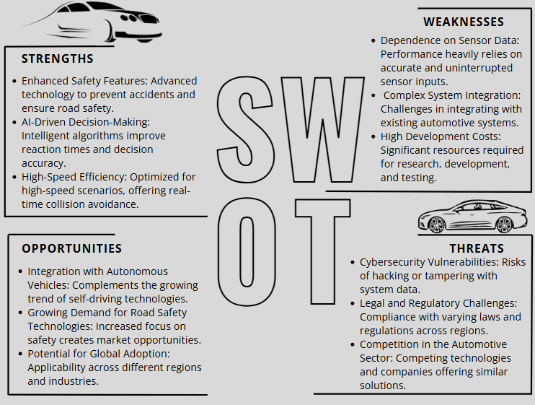

*Figure 2-1 - SWOT Analysis*

##### The 7 P’s

*Table 4 - 7 P's*

|  |  |
| --- | --- |
| **The P** | **Description** |
| **Product** | **Core Offering**: Adaptive Collision Avoidance System designed for high-speed  driving   * Sensor-based speed and distance management.   • Integration with autonomous driving systems.   * AI-driven real-time collision detection and avoidance   **Value Proposition:** Enhanced road safety, reduced accidents, and  optimized driving experiences**.** |
| **Price** | * **Premium Pricing** for early adopters and luxury vehicle manufacturers. * **Dynamic Pricing** for mass-market adaptation based on production scale and adoption rates.   **Cost Justification**: The high initial price reflects the advanced technology and R&D efforts. |
| **Place** | **Distribution Channels**:   * **Direct partnerships with automotive manufacturers.** * **Integration into OEM (Original Equipment Manufacturer) supply chains.** * Online marketing for B2B clients in the automotive sector.   **Market Coverage**: Focus on regions with high vehicular traffic and strong safety regulations. |
| **Promotion** | **Marketing Strategies**:   * **B2B Campaigns**: Collaborate with car manufacturers and fleet operators. * **Trade Shows and Exhibitions**: Demonstrate technology at automotive expos. * **Digital Marketing**: Targeted ads and campaigns on LinkedIn and industry forums. * **Safety Campaigns**: Showcase real-world benefits in accident prevention. |
| **People** | **Key Stakeholders**:   * **Automotive manufacturers.** * Research and development teams for continuous improvement. * End-users (drivers) who value safety and technology.   **Customer Support**: Provide training for auto technicians and user-friendly manuals. |
| **Process** | **Development Process**:   * Agile development to test and refine the system. * Collaboration with automotive design teams for seamless integration.   **Customer Experience**:   * Simple, intuitive system interfaces. * Regular updates for improving system performance and compliance. |
| **Physical Evidence** | **Physical Evidence**   * **Proof of Concept**: Test cases and simulations demonstrating collision avoidance success. * **Product Design**: Sleek, compact hardware for easy installation in vehicles. * **Certifications**: Compliance with safety standards and industry regulations (e.g., ISO certifications for automotive safety). |

##### PESTEL Analysis

*Figure 2-2 - PESTEL Analysis*

##### Similar Projects

This section reviews similar projects, focusing on their features, strengths, and weaknesses. By analyzing these, we can identify gaps and opportunities to improve our proposed solution.

* Adaptive cruise control (ACC)

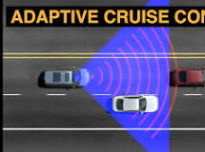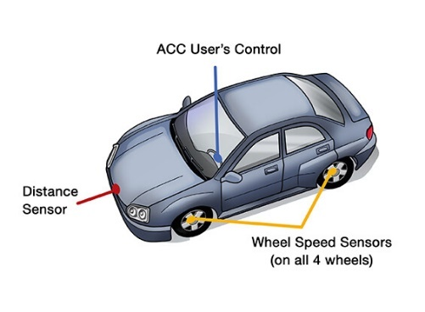

Description

Adaptive cruise control (ACC) is an enhancement of conventional cruise control. ACC automatically adjusts the speed of your car to match the speed of the car in front of you. If the car ahead slows down, ACC can automatically match it.

Once the car ahead moves out of your lane or accelerates beyond your car’s set speed, your ACC allows your car to return to the speed that you have set. Other than setting your speed, you only need to turn on the system and select your preferred following distance.

Features:

* Automatic Speed Adjustment: Adjusts the vehicle’s speed to maintain a safe following distance from the vehicle ahead.
* Distance Settings: Allows the driver to set preferred following distance, typically measured in time (e.g., 2 seconds gap).
* Collision Avoidance Support: Detects slower-moving vehicles ahead and reduces speed to prevent rear-end collisions.
* Integration with Other Systems: Often works with lane-keeping assist, emergency braking, and other advanced driver-assistance systems (ADAS).
* Stop-and-Go Functionality: Can bring the vehicle to a complete stop in traffic and resume when conditions permit (in some systems).
* Sensor-Based Operation: Uses radar, cameras, or lidar to monitor the road and detect vehicles in the ACC's field of view.
* Smooth Acceleration and Deceleration: Ensures comfortable speed adjustments without sudden changes.
* Driver Alerts: Provides warnings if driver intervention is needed or if the system detects limitations in functionality.
* Customizable Settings: Allows users to select speed limits and sensitivity levels based on driving preferences.
* Curvature Adaptation (in advanced models): Adjusts speed when detecting curves on the road, improving handling.

**Cons:**

- Limited Field of View: The ACC system only looks directly ahead, which restricts its ability to detect vehicles on curving roads.

Misidentification of Traffic: The system may include traffic from other lanes within its field of view, leading to inaccurate responses.

Missed Detection: Vehicles in your own lane may be missed due to the limited scope of the ACC's forward-looking sensors.

Inappropriate Reactions: The system may react unexpectedly, such as slowing down unnecessarily when it detects a vehicle (e.g., a semi-truck) in an adjacent lane.

Safety Concerns on Curves: These limitations can lead to potential safety issues, especially on roads with significant curves.

Pros:

Enhanced Comfort: Automatically adjusts the vehicle’s speed to maintain a safe following distance, reducing the need for constant speed adjustments by the driver.

Improved Safety: Helps prevent tailgating and reduces the risk of rear-end collisions by maintaining consistent spacing between vehicles.

Traffic Adaptation: Smoothly adjusts speed in response to changing traffic conditions, reducing driver stress in stop-and-go scenarios.

Fuel Efficiency: Promotes smoother driving behavior, which can contribute to better fuel economy compared to manual acceleration and braking.

Driver Assistance: Acts as a supportive feature during long drives, reducing driver fatigue by handling speed management.

Foundation for Advanced Systems: Serves as a stepping stone toward more advanced driver-assistance systems and autonomous driving technologies.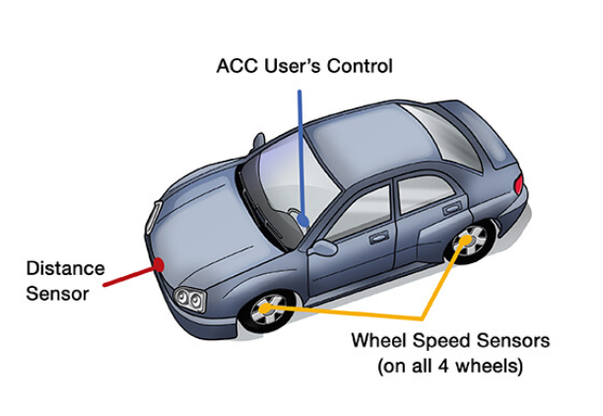

Autonomous Emergency Braking (AEB)

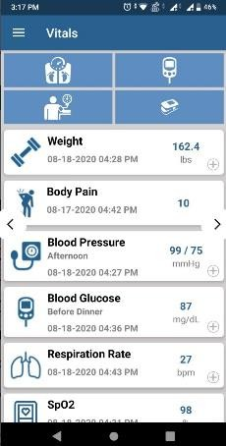

Description: Autonomous Emergency Braking (AEB) systems use sensors to detect the presence of a potential hazard in front of the vehicle and, where the driver has not done so in time, to apply the brakes to avoid a collision or to mitigate its severity.

**Features of Autonomous Emergency Braking (AEB):**

1. **Hazard Detection**: Uses sensors like cameras, radars, and lidars to detect potential hazards in front of the vehicle.
2. **Sensor Fusion**: Combines multiple sensor types for improved detection accuracy and functionality across speed ranges.
3. **Forward Collision Warning**: Alerts the driver of potential hazards before initiating emergency braking.
4. **Automatic Braking**: Applies brakes autonomously if the driver fails to respond in time, either avoiding a collision or mitigating its severity.
5. **Wide Speed Range Functionality**: Effective across city speeds (AEB City) and highway speeds (AEB Inter-Urban).
6. **Multi-Scenario Testing**: Assessed in conditions like stopped vehicles, slower-moving vehicles, decelerating vehicles, and junction scenarios.
7. **Offset Detection**: Recognizes hazards even when the target vehicle is not perfectly aligned with the test vehicle.
8. **Global Vehicle Target (GVT)**: Utilizes advanced 3D targets for realistic testing of sensor performance.
9. **Scenario Expansion**: Includes tests for side-road turns and junction crossings with varying speed combinations.
10. **Protection for Vulnerable Road Users**: Separate assessments for pedestrians, cyclists, and motorcyclists (added from 2023)

### Pros of AEB:

1. **Enhanced Safety**: Reduces the likelihood and severity of rear-end collisions.
2. **Injury Prevention**: Minimizes injuries in low-speed crashes, such as whiplash in city environments.
3. **Versatility**: Functions across a broad speed range, making it effective in urban and highway conditions.
4. **Improved Reaction Times**: Detects hazards and applies brakes faster than human reflexes in emergency situations.
5. **Technological Advancements**: Modern systems use sensor fusion for high accuracy and reliability.
6. **Support in Complex Scenarios**: Handles challenging conditions like junction crossings and side-road turns.
7. **Reduction in Crash Severity**: Even if a collision cannot be avoided, AEB can significantly lower the impact speed.
8. **Regulatory and Safety Standards**: Tested and validated by agencies like Euro NCAP, ensuring adherence to high safety benchmarks.
9. **Promotes Safer Driving Habits**: Alerts drivers of hazards, encouraging more attentive driving.
10. **Vulnerable User Protection**: Expands safety benefits to pedestrians, cyclists, and motorcyclists.

**Cons of AEB:**

1. **Limited Effectiveness**: May not avoid collisions entirely in challenging situations or high-speed scenarios.
2. **Sensor Blind Spots**: Can struggle with detecting certain hazards, such as small objects or vehicles in extreme conditions.
3. **Over-Reliance Risk**: Drivers might depend excessively on AEB, reducing their attentiveness.
4. **Performance in Complex Scenarios**: May not react adequately in situations with sudden or unpredictable hazards.
5. **False Positives**: Can mistakenly detect hazards, leading to unnecessary braking and potential rear-end collisions.
6. **System Limitations**: Effectiveness can be reduced in adverse weather conditions (e.g., heavy rain, fog) or poor road visibility.
7. **Cost**: Adds to the overall cost of the vehicle due to advanced sensors and technology.
8. **Repair Expenses**: Damage to sensors or calibration issues after an accident can be costly to fix.
9. **Partial Testing Scope**: While tested extensively, not all real-world scenarios are accounted for in certification processes.
10. **Compatibility Issues**: May not work seamlessly with older infrastructure or vehicles without similar systems.

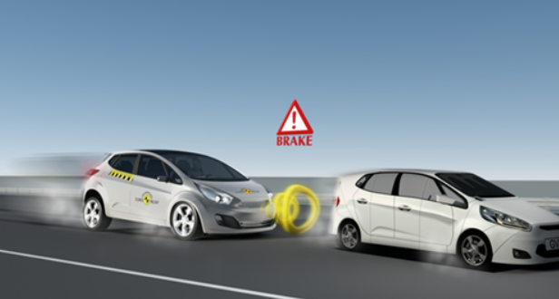

Forward-Collision Warning System (FCW)

Description: A Forward-Collision Warning (FCW) system, also known as Forward-Collision Alert, is an advanced driver assistance system (ADAS) designed to prevent rear-end collisions by warning drivers of imminent obstacles. It uses sensors to detect vehicles, pedestrians, and stationary objects in the vehicle's path and provides alerts for the driver to act promptly.

### ****Key Features of FCW Systems****

* **Sensors and Detection**:
  + Equipped with front-facing sensors, cameras, or radar.
  + Detects vehicles, pedestrians, and obstacles.
* **Alerts**:
  + Provides visual, audible, or haptic warnings (e.g., vibrating steering wheel or seat).
* **Integration with ADAS**:
  + Often combined with **Automatic Emergency Braking (AEB)** for enhanced safety.
  + Can include adaptive cruise control and semi-autonomous driving features.
* **Field of View and Range**:
  + Some systems offer broader fields of view or extended detection ranges.
* **Brand-Specific Systems**:
  + Examples include **Honda Sensing**, **Audi Pre Sense**, and **Mercedes-Benz Active Brake Assist**.
* **Additional Features**:
  + Intersection turn assistance.
  + Pedestrian and cyclist detection.

**Pros of FCW Systems**

1. **Enhanced Safety**:
   * Reduces the likelihood of rear-end collisions by up to **27%** (as per IIHS data).
   * Mitigates accidents in heavy traffic or urban areas.
2. **Life-Saving Technology**:
   * Protects drivers, passengers, pedestrians, and cyclists.
3. **Versatility**:
   * Functions in various environments and road conditions.
   * Compatible with multiple ADAS technologies.
4. **Increased Vehicle Value**:
   * Standard or optional in many newer vehicle models.
5. **Ease of Use**:
   * Alerts allow drivers to act before an automated system intervenes.

**Cons of FCW Systems**

1. **False Alarms**:
   * May issue warnings unnecessarily, especially in heavy traffic or with sharp curves.
2. **Dependency on Sensors**:
   * Adverse weather (e.g., snow, fog) can affect sensor accuracy.
3. **Complexity and Cost**:
   * Adds to vehicle cost.
   * Repairs can be expensive if sensors or cameras are damaged.
4. **Proprietary Branding Confusion**:
   * Varying terminology across automakers can make it challenging for consumers to identify the feature.
5. **Driver Overreliance**:
   * May lead to complacency, assuming the system will always prevent accidents.

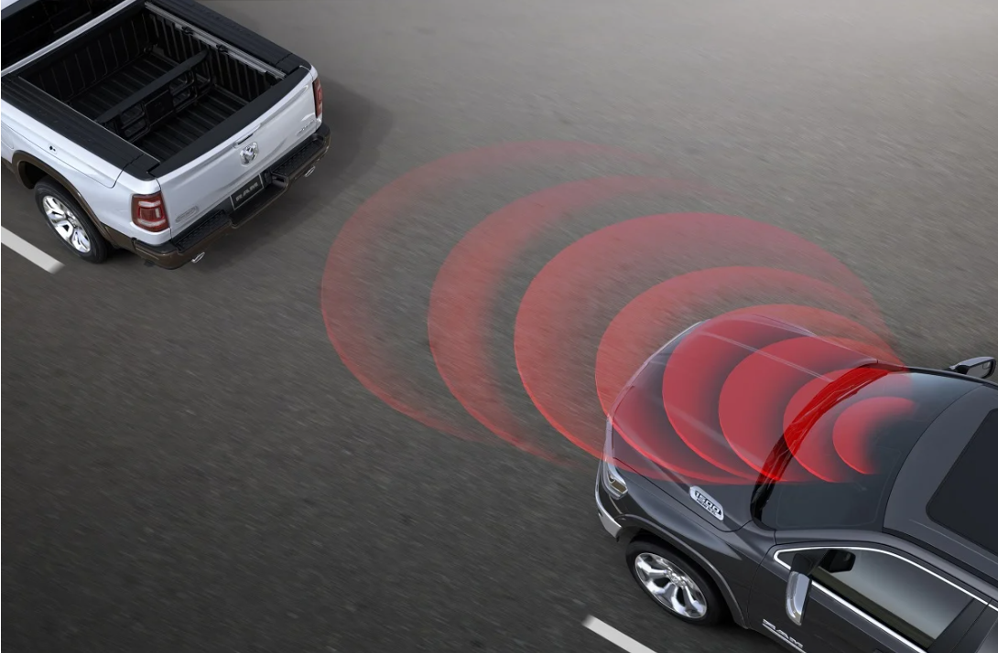

* + The **Collision Mitigation Braking System (CMBS)**

Description: The **Collision Mitigation Braking System (CMBS)** is an advanced safety feature designed to prevent or reduce the severity of collisions. It actively intervenes when it detects a potential collision, providing warnings and, if necessary, applying the brakes to mitigate the impact.

Features:

**Automatic Braking**:

* Proactively reduces vehicle speed to avoid or lessen the impact of a collision.

**Multi-Scenario Detection**:

* Operates in scenarios involving other vehicles, pedestrians, or stationary objects.

**Enhanced Responsiveness**:

* Reacts faster than human reflexes to imminent dangers.

**Adjustable Sensitivity**:

* Allows drivers to set thresholds for system activation (in some vehicles).

**Low-Speed and High-Speed Functionality**:

* Works in both urban stop-and-go traffic and higher-speed highway scenarios.

**Pros of CMBS**

1. **Accident Prevention**:
   * Reduces the likelihood of rear-end collisions.
   * Minimizes damage in unavoidable accidents.
2. **Safety Enhancement**:
   * Protects occupants, pedestrians, and other road users.
3. **Driver Assistance**:
   * Acts as a backup to human error, especially during distractions or fatigue.
4. **Lower Insurance Costs**:
   * Vehicles equipped with CMBS often qualify for insurance discounts.

**Cons of CMBS**

1. **False Alarms**:
   * May activate unnecessarily in specific scenarios, such as sudden braking by the vehicle ahead or misinterpreting objects on the road.
2. **Limited Effectiveness**:
   * May struggle with certain road conditions (e.g., heavy rain, snow, fog).
   * Not always effective at very high speeds.
3. **Cost**:
   * Adds to the vehicle's price.
   * Repairs can be expensive if sensors are damaged.
4. **Overreliance**:
   * Drivers may become complacent, relying on the system instead of maintaining focus.

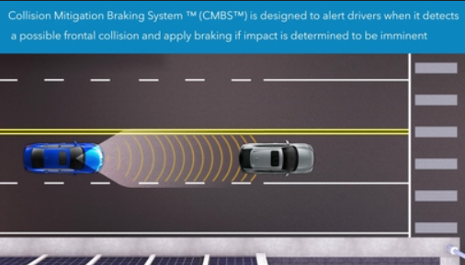

‘

**Traffic Jam Pilot**

Description:

**Traffic Jam Pilot** is Audi's advanced driver assistance system (ADAS) that offers a semi-autonomous driving experience in specific conditions, primarily designed for slow-moving traffic on highways. It represents a step toward autonomous driving by managing driving tasks under certain limitations.

**Key Features of Traffic Jam Pilot**

1. **Hands-Free Driving**:
   * Allows drivers to take their hands off the wheel and focus on non-driving tasks under specific conditions.
2. **Lane Keeping and Following**:
   * Maintains the vehicle's position within the lane while adjusting speed to follow traffic.
3. **Safety Precautions**:
   * Alerts the driver to regain control if traffic conditions change or if the system's limitations are reached.
4. **Enhanced Sensing Capabilities**:
   * Uses **LiDAR technology**, which offers detailed environmental mapping for better decision-making.

**Pros of Traffic Jam Pilot**

1. **Stress Reduction**:
   * Reduces driver fatigue in heavy traffic by handling monotonous driving tasks.
2. **Increased Safety**:
   * Reacts faster than human drivers in stop-and-go traffic, reducing the risk of rear-end collisions.
3. **Technological Advancement**:
   * Represents a significant step toward fully autonomous driving.
4. **Efficiency**:
   * Optimizes braking and acceleration, potentially improving fuel efficiency in traffic conditions.

**Cons of Traffic Jam Pilot**

1. **Limited Availability**:
   * Only available in certain markets and on specific Audi models (e.g., Audi A8).
   * Requires legal approval for use in various regions, as regulations around semi-autonomous systems differ.
2. **Operational Constraints**:
   * Only works under strict conditions (low-speed highway traffic, clear lane markings).
   * The driver must be ready to take over control at all times.
3. **Cost**:
   * Increases the overall cost of the vehicle.

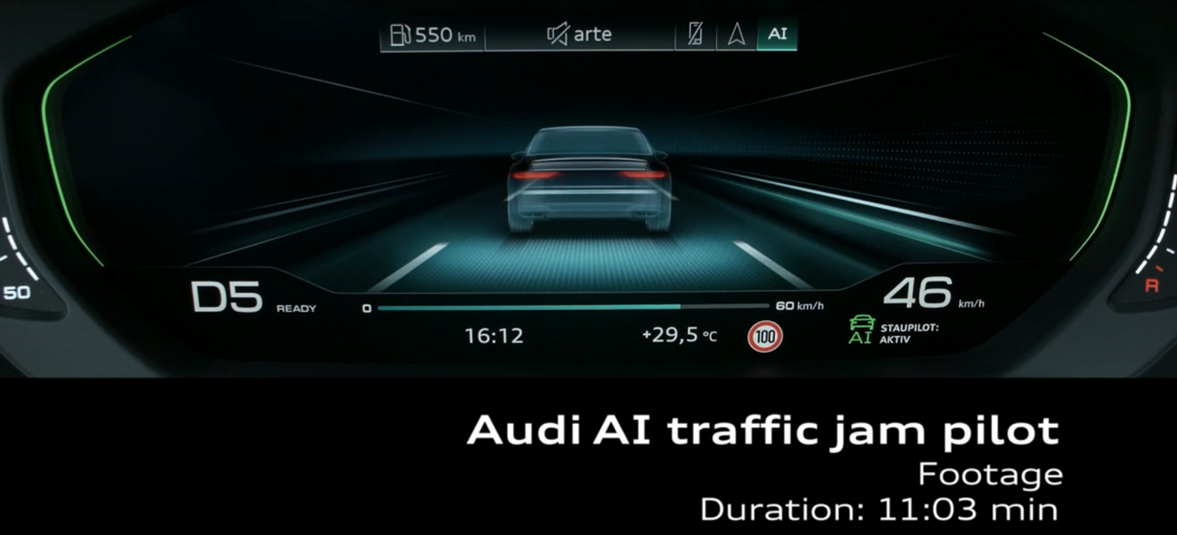

**Intelligent Speed Assistance (ISA)**

**Intelligent Speed Assistance (ISA)** ensures vehicles do not exceed safe or legally enforced speed limits. It uses systems like GPS and road sign recognition to determine speed limits. ISA can either alert the driver when they exceed the limit or automatically reduce the vehicle's speed.

### ****Key Features:****

* **Active and Passive Systems**: Active reduces speed, passive alerts the driver.
* **Speed and Location Verification**: Uses GPS, radio beacons, or optical recognition.

### ****Pros****:

* Enhances safety by preventing speeding.
* Can reduce accidents.
* Integrates well with other ADAS.

### ****Cons****:

* Driver may override the system.
* May be intrusive or reduce driving enjoyment.

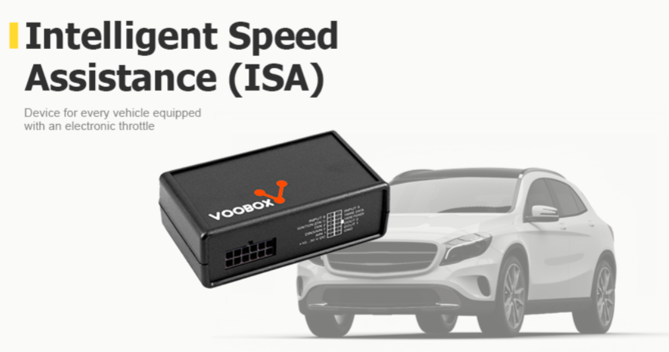

*Table 5 - Similar Projects Comparison*

|  |  |  |  |  |  |  |
| --- | --- | --- | --- | --- | --- | --- |
| **System Name** | **Key Features** | **Proximity Detection** | **Speed Adjustment** | **Alert Mechanism** | **Autonomous Action** | **Differentiation** |
| Adaptive Cruise Control (ACC) | Maintains a constant speed and adjusts speed based on surrounding traffic | Radar, lidar, or camera sensors detect nearby vehicles | Adjusts vehicle speed to maintain a set distance | Audible alert when a vehicle comes too close | Automatically reduces speed when necessary | Does not adjust speed incrementally based on varying proximity; set distance intervals |
| Autonomous Emergency Braking (AEB) | Detects imminent collisions and applies brakes automatically. | Radar, lidar, or camera sensors for collision detection . | No speed adjustment; applies brakes if collision risk is imminent | Visual or audible alert to warn the driver | Applies brakes autonomously when imminent collision is detected | Typically only brakes in emergency situations, no gradual speed adjustment |
| Forward Collision Warning (FCW) | Warns drivers of an imminent collision based on proximity to other vehicles | Radar and cameras monitor traffic conditions | No speed adjustment, only alerts | Visual or audible warning when a collision risk is detected | No autonomous action, only alerts the driver | Does not automatically intervene to adjust speed |
| Collision Mitigation Braking System (CMBS) | Reduces the likelihood of a collision by braking the vehicle . | * Vital sign tracking across specialties. * HER integration. * Predictive analytics for early interventions. | Applies brakes autonomously when a collision risk is detected | Audible and visual alerts | Applies brakes to mitigate collision risk, does not manage speed incrementally | Focuses mainly on braking without gradual speed reduction or dynamic adjustment |
| Traffic Jam Pilot (Audi) | Autonomous driving in low-speed traffic situations | Uses radar, ultrasonic sensors, and cameras to monitor surroundings | Controls throttle and braking for maintaining safe distance | Alerts and feedback for driver to take control | Fully autonomous speed control in low-speed conditions | Specifically for low-speed driving, does not adjust speed at high speeds or dynamically |
| Intelligent Speed Adaptation (ISA) | Adjusts vehicle speed according to road conditions and traffic signs. | Camera and GPS-based systems for speed limits and traffic conditions | Automatically adjusts speed to match legal speed limits and safe driving conditions | Visual alerts for approaching speed limits or hazards | Automatically adjusts speed but no proximity-based adjustment | Primarily focuses on road speed limits, not proximity to surrounding vehicles |

| **System Name** | **Key Features** | **Proximity Detection** | **Speed Adjustment** | **Alert Mechanism** | **Autonomous Action** | **Differentiation** | **AI-Powered Traffic Prediction and Congestion Analysis** |
| --- | --- | --- | --- | --- | --- | --- | --- |
| Adaptive Cruise Control (ACC) | Maintains a constant speed and adjusts speed based on surrounding traffic | Radar, lidar, or camera sensors detect nearby vehicles | Adjusts vehicle speed to maintain a set distance | Audible alert when a vehicle comes too close | Automatically reduces speed when necessary | Does not adjust speed incrementally based on varying proximity; set distance intervals | Limited; no predictive traffic analysis, relies on fixed-distance adjustments |
| Autonomous Emergency Braking (AEB) | Detects imminent collisions and applies brakes automatically. | Radar, lidar, or camera sensors for collision detection | No speed adjustment; applies brakes if collision risk is imminent | Visual or audible alert to warn the driver | Applies brakes autonomously when imminent collision is detected | Typically only brakes in emergency situations, no gradual speed adjustment | Does not anticipate congestion; only responds to immediate threats |
| Forward Collision Warning (FCW) | Warns drivers of an imminent collision based on proximity to other vehicles | Radar and cameras monitor traffic conditions | No speed adjustment, only alerts | Visual or audible warning when a collision risk is detected | No autonomous action, only alerts the driver | Does not automatically intervene to adjust speed | No predictive traffic capability, focuses solely on real-time detection |
| Collision Mitigation Braking System (CMBS) | Reduces the likelihood of a collision by braking the vehicle. | Radar and sensors | Applies brakes autonomously when a collision risk is detected | Audible and visual alerts | Applies brakes to mitigate collision risk, does not manage speed incrementally | Focuses mainly on braking without gradual speed reduction or dynamic adjustment | Lacks predictive analysis, only reacts to detected hazards |
| Traffic Jam Pilot (Audi) | Autonomous driving in low-speed traffic situations | Uses radar, ultrasonic sensors, and cameras to monitor surroundings | Controls throttle and braking for maintaining safe distance | Alerts and feedback for driver to take control | Fully autonomous speed control in low-speed conditions | Specifically for low-speed driving, does not adjust speed at high speeds or dynamically | Limited to low-speed scenarios, cannot predict high-speed congestion |
| Intelligent Speed Adaptation (ISA) | Adjusts vehicle speed according to road conditions and traffic signs. | Camera and GPS-based systems for speed limits and traffic conditions | Automatically adjusts speed to match legal speed limits and safe driving conditions | Visual alerts for approaching speed limits or hazards | Automatically adjusts speed but no proximity-based adjustment | Primarily focuses on road speed limits, not proximity to surrounding vehicles | No traffic prediction; adjusts based on static speed limits |
| **Adaptive Collision Avoidance System** | **Combines proximity sensors, radar technology, and AI-powered traffic prediction for dynamic collision avoidance** | **Ultrasonic and radar sensors for 360-degree detection** | **Dynamically adjusts speed based on traffic patterns and proximity** | **Visual and auditory alerts with predictive analysis** | **Autonomous speed adjustment and collision prevention** | **Surpasses limitations of existing systems by analyzing real-time traffic, predicting congestion, and preventing rear-end collisions proactively** | **Uses AI to anticipate congestion, enabling proactive adjustments to prevent potential collisions and traffic disruptions** |

**How Our System Integrates the Benefits of Existing Systems?**

|  |  |  |
| --- | --- | --- |
| **Features** | **Your System Integration** | **How it Combines the Best Features of Existing Systems** |
| Proximity Detection | Ultrasonic and radar sensors to continuously measure distance to surrounding vehicles. | Integrates the best proximity sensing technologies from ACC, AEB, FCW, and CMBS. More precise detection with dynamic responses based on varying distances. |
| Distance Calculation | Real-time calculation of distances and relative speed using sensor | Utilizes the approach from AEB and ACC to calculate distances, but with added precision for dynamic speed adjustment. |
| Alert Mechanism | Visual and auditory alerts when a vehicle enters a predefined unsafe distance. | Combines alerts from FCW and CMBS with a dynamic approach to warn drivers based on varying proximity.. |
| Speed Adjustment | Gradual speed reduction in proportion to the proximity of surrounding vehicles | Combines features from ACC and CMBS but adds a dynamic and proportional adjustment, unlike existing systems that use fixed thresholds. |
| Autonomous Action | If the driver doesn't react, the system will automatically adjust the vehicle's speed or apply brakes. | Merges the autonomous braking functionality of AEB and CMBS with proportional speed reduction for smoother, safer operation. |
| Driver Feedback | Continuous feedback to the driver for both alerts and speed adjustments. | Builds on the driver alerts from AEB, ACC, and FCW while allowing for more intuitive control through gradual adjustments. |
| Real-time Data Processing | Real-time processing of sensor data to make quick decisions without delay. | Emulates AEB's real-time decision-making while ensuring that decisions are based on dynamic proximity, unlike ACC's preset thresholds. |
| AI-Powered Traffic Prediction and Congestion Analysis | Utilizes AI to predict traffic patterns and congestion, enabling proactive adjustments to prevent delays and enhance safety | Combines insights from all existing systems and augments them with predictive analytics for a comprehensive, future-ready solution. |

|  |  |  |  |  |  |
| --- | --- | --- | --- | --- | --- |
| System Name | Proximity Detection | Speed Adjustment | Alert Mechanism | Autonomous Action | **AI-Powered Traffic Prediction and Congestion Analysis** |
| Adaptive Cruise Control (ACC) | **√** | **√** | **√** | **√** |  |
| Autonomous Emergency Braking (AEB) | **√** |  | **√** | **√** |  |
| Forward Collision Warning (FCW) | **√** |  | **√** |  |  |
| Collision Mitigation Braking System (CMBS) | **√** |  | **√** | **√** |  |
| Traffic Jam Pilot (Audi) | **√** | **√** | **√** | **√** |  |
| Intelligent Speed Adaptation (ISA) | **√** | **√** | **√** |  |  |
| Our Adaptive Collision Avoidance System | **√** | **√** | **√** | **√** | **√** |

**Comparison of Adaptive Collision Avoidance Features**

#### Background

The integration of machine learning (ML) and artificial intelligence (AI) methodologies with automotive technologies has significantly advanced the field of vehicular safety, particularly in high-speed driving scenarios. By combining ML algorithms with proximity sensors, smart radar systems, and real-time traffic prediction, innovative solutions are emerging to address critical challenges in collision avoidance and road safety. Various AI and ML techniques have been employed to enhance these technologies, offering unique advantages such as proactive risk mitigation, dynamic speed adjustment, and enhanced environmental awareness. These advancements aim to address specific safety needs in high-speed driving, ensuring safer driving experiences by preventing accidents before they occur.

**1.Proximity Detection:**

The primary objective of this feature is to detect nearby objects and other vehicles, ensuring that the system can assess the relative distance and potential risk.

Algorithm:

The **Time-of-Flight (ToF)** algorithm is used to measure the distance between a sensor and an object by calculating the time it takes for a signal (ultrasonic sound or electromagnetic wave) to travel to the object and back to the sensor. This method is commonly employed in both **ultrasonic** and **radar sensors**.

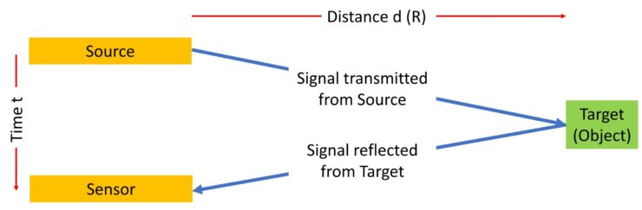

*Reference:* [*https://www.terabee.com/time-of-flight-principle/*](https://www.terabee.com/time-of-flight-principle/)

**2.Speed Adjustment (Dynamic Speed Regulation):**

This feature adjusts the vehicle's speed in response to detected obstacles or changing traffic conditions.

Algorithm:

A **PID algorithm** (Proportional-Integral-Derivative) is a control loop feedback mechanism commonly used in industrial control systems and other applications requiring continuous control. It is designed to ensure that a system operates at a desired setpoint by minimizing the error between the setpoint and the actual output.

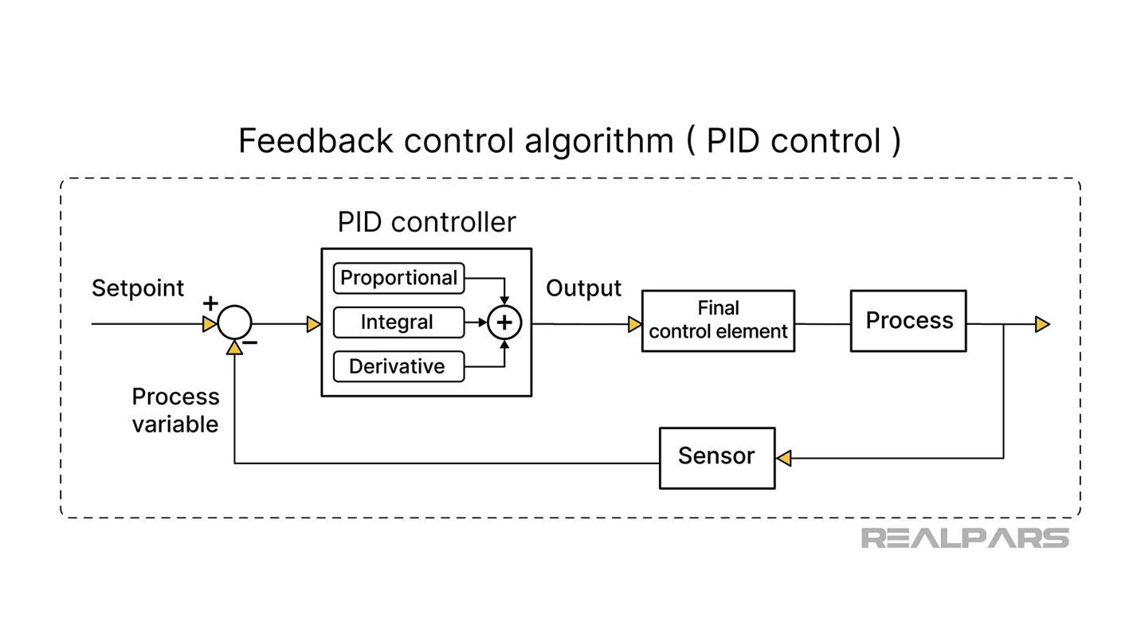

*Reference:* [*https://www.veichi.com/knowledge/what-is-pid-control-algorithm.html#:~:text=For%20PID%20control%20algorithm%2C%20there,position%20type%20algorithm%2C%20differential%20algorithm*](https://www.veichi.com/knowledge/what-is-pid-control-algorithm.html#:~:text=For%20PID%20control%20algorithm%2C%20there,position%20type%20algorithm%2C%20differential%20algorithm)*.*

[*https://www.realpars.com/blog/pid-vs-advanced-control-methods*](https://www.realpars.com/blog/pid-vs-advanced-control-methods)*.*

*OR*

Fuzzy logic: can be a great way to implement speed adjustment in systems where the relationship between input and output is complex or difficult to model using traditional control techniques. It's often used in situations where the system's behavior is uncertain or vague. For example, in speed control systems like in motors, vehicles, or fans, fuzzy logic can be used to adjust speed smoothly based on various input parameters such as desired speed, load, or environmental conditions.

**3.Alert Mechanism (Visual and Auditory Alerts):**

This feature is responsible for notifying the driver about potential collision risks and speed violations.

Algorithm:

### Threshold-Based Alarm System with Event-Triggered Logic: Algorithm

A **Threshold-Based Alarm System** with **Event-Triggered Logic** is typically used in systems where alarms are raised based on certain conditions crossing predefined thresholds, but only when significant changes (or "events") occur. This reduces unnecessary alarms triggered by small fluctuations, focusing only on significant changes.

*Reference:*

**4. Autonomous Action (Automated Speed Adjustment and Braking)**

This feature is responsible for automatically intervening if the driver does not respond to the alerts or if a collision risk is imminent.

Algorithm:

A **PID algorithm** (Proportional-Integral-Derivative) is a control loop feedback mechanism commonly used in industrial control systems and other applications requiring continuous control. It is designed to ensure that a system operates at a desired setpoint by minimizing the error between the setpoint and the actual output.



*Reference:* [*https://www.veichi.com/knowledge/what-is-pid-control-algorithm.html#:~:text=For%20PID%20control%20algorithm%2C%20there,position%20type%20algorithm%2C%20differential%20algorithm*](https://www.veichi.com/knowledge/what-is-pid-control-algorithm.html#:~:text=For%20PID%20control%20algorithm%2C%20there,position%20type%20algorithm%2C%20differential%20algorithm)*.*

[*https://www.realpars.com/blog/pid-vs-advanced-control-methods*](https://www.realpars.com/blog/pid-vs-advanced-control-methods)

5.predict potential traffic jams:

**XGBoost (Extreme Gradient Boosting)** is a highly efficient, scalable, and flexible machine learning algorithm that has become very popular for supervised learning tasks, especially for structured/tabular data. It's an implementation of gradient boosting, which is an ensemble learning method.

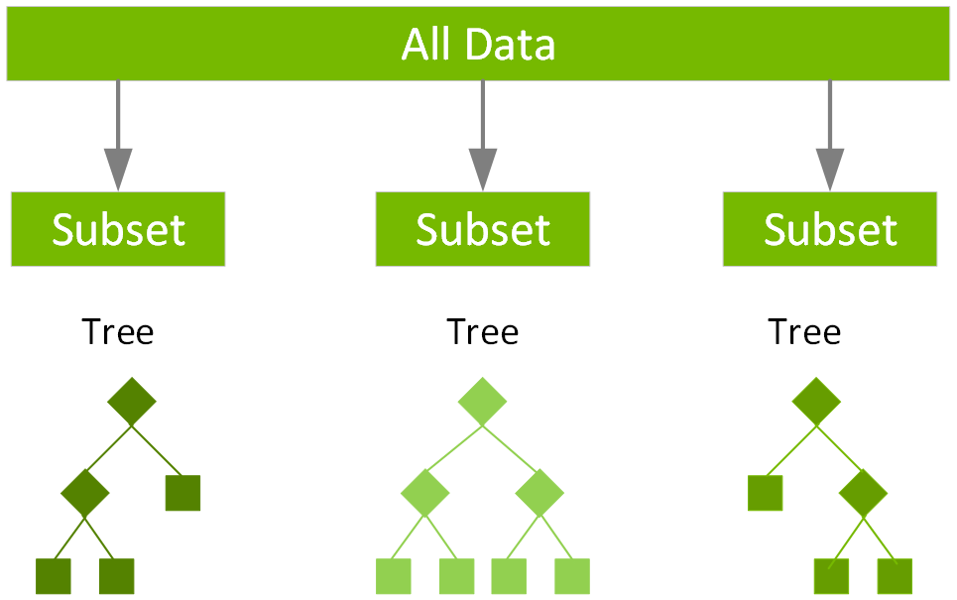

**Reference:** <https://simplilearn.com/what-is-xgboost-algorithm-in-machine-learning-article>

*.*

**Literature Review:**

The increasing frequency of accidents in high-speed driving environments has highlighted the critical need for enhanced safety systems. Collision avoidance systems, such as Automatic Emergency Braking (AEB), Adaptive Cruise Control (ACC), and Lane Departure Warning (LDW), have been widely deployed to mitigate risks in lower-speed scenarios. However, these systems often struggle to operate effectively at high speeds or in complex traffic conditions. This literature review explores the evolution of collision avoidance technologies, focusing on proximity sensors, radar systems, machine learning (ML), and artificial intelligence (AI), and their integration into adaptive systems that can operate efficiently at high speeds.

**1. Collision Avoidance Systems in High-Speed Driving**

Traditional collision avoidance systems, such as AEB and ACC, are designed to prevent accidents by automatically adjusting the vehicle's speed or steering in response to detected risks. These systems primarily rely on radar, cameras, and ultrasonic sensors to monitor the surrounding environment.

**Existing Systems and Technologies:**

* **Adaptive Cruise Control (ACC)**: ACC systems maintain a safe distance between vehicles by automatically adjusting the speed. However, at high speeds, these systems face challenges in accurately predicting sudden changes in traffic behavior and preventing rear-end collisions in fast-moving traffic (Bose et al., 2021).
* **Automatic Emergency Braking (AEB)**: AEB systems detect an impending collision and apply the brakes to reduce the severity of the impact. While AEB is effective at low speeds, its performance at high speeds, especially in high-traffic environments, has been questioned (Smith et al., 2020). AEB systems often struggle in adverse weather conditions and can fail to predict dynamic traffic changes.

**Challenges in High-Speed Environments:**

* **Limited Sensor Range and Precision**: At high speeds, the ability to predict and react to traffic changes diminishes, especially when relying solely on traditional radar and cameras. The distance and time required to react in high-speed environments pose significant safety concerns (Hernandez et al., 2019).
* **Weather Conditions**: Sensors like radar and cameras can be affected by adverse weather, such as fog, rain, or snow, leading to reduced system reliability (Chung et al., 2021).

**2. Proximity Sensors and Radar Technology**

Radar technology, including millimeter-wave radar and ultrasonic sensors, is crucial for detecting obstacles and measuring distances in real-time, even in adverse conditions. These sensors are commonly used in proximity-based collision avoidance systems.

* **Radar Sensors**: Radar sensors offer advantages over traditional cameras by detecting objects at long ranges and providing high-resolution data, especially in poor weather conditions. Lee et al. (2022) demonstrated that smart radar systems with 360-degree coverage improve real-time detection of surrounding vehicles, significantly reducing the risk of rear-end collisions.
* **Ultrasonic Sensors**: While limited in range, ultrasonic sensors are often used in conjunction with radar and cameras for close-range detection. These sensors are effective in parking assist systems and low-speed collision prevention but are less useful in high-speed scenarios (Chung et al., 2021).
* **Radar and Sensor Fusion**: The integration of radar with other sensors (e.g., LiDAR, cameras, and ultrasonic sensors) allows for a more comprehensive view of the driving environment. This sensor fusion technology has shown promise in improving the reliability and accuracy of collision avoidance systems (Sullivan et al., 2021).

**3. Machine Learning and AI for Traffic Prediction**

Machine learning and AI methodologies have revolutionized the ability to predict traffic patterns and adjust vehicle behavior in real-time. These technologies can analyze vast amounts of data from sensors and traffic signals to make adaptive decisions that enhance safety.

* **Traffic Prediction Models**: AI-based models like Convolutional Neural Networks (CNNs) and Long Short-Term Memory (LSTM) networks have been used for predicting traffic congestion and driver behavior. Zhang et al. (2023) applied CNNs to predict real-time traffic conditions and improve decision-making for collision avoidance systems.
* **Real-Time Decision-Making**: AI algorithms can integrate data from radar, cameras, and traffic prediction models to continuously adjust the vehicle’s speed and braking behavior. Kim et al. (2022) demonstrated how AI could be used to proactively adjust speed based on real-time traffic analysis, thus reducing the likelihood of rear-end collisions.
* **AI and Adaptive Systems**: The combination of AI with radar sensors allows for a more adaptive approach to collision prevention. AI can predict the behavior of surrounding vehicles and adjust speed, taking into account factors such as road conditions, traffic flow, and vehicle proximity (Zhang et al., 2022).

**4. Radar Speed Compliance and Safety**

Radar-based systems are also integral to ensuring speed compliance. These systems detect speed limits and adjust the vehicle’s speed to adhere to legal requirements, which is particularly important in high-speed environments where speed variations can significantly impact safety.

* **Speed Regulation**: Radar systems that monitor speed limits and detect surrounding vehicles have been integrated into adaptive cruise control systems to ensure compliance with traffic regulations. Sullivan et al. (2021) explored radar’s ability to detect posted speed limits and adjust vehicle speed automatically, thus improving safety in areas with frequent speed changes.
* **Enhanced Safety Features**: Radar speed compliance systems are designed to work in conjunction with proximity sensors to dynamically adjust the vehicle’s speed based on real-time data. This approach enhances safety by preventing speeding while also responding to potential collision risks (Lee et al., 2022).

**5. Gaps in Current Research and the Need for Improvement**

Despite the advancements in collision avoidance systems, several challenges remain, particularly in high-speed driving scenarios. Many existing systems rely on static algorithms that cannot fully account for unpredictable traffic behavior or sudden changes in road conditions. The integration of AI and machine learning offers a promising solution to these limitations, providing the ability to dynamically adjust vehicle behavior based on real-time traffic data.

* **Limitations of Existing Systems**: Many current systems are not well-suited to handle high-speed driving environments, where split-second decisions are necessary. Furthermore, the reliability of these systems in adverse weather conditions remains a challenge (Garcia et al., 2022).
* **Potential for Innovation**: The integration of advanced radar systems with AI-powered traffic prediction and adaptive decision-making processes holds the potential to significantly improve safety in high-speed driving environments. By dynamically adjusting vehicle behavior based on real-time data, the proposed system can address the gaps in current technologies and provide a more effective collision avoidance solution

| **Paper Authors and Year** | **Key Methodologies** | **Applications** | **Unique Contributions** | **Pros** | **Cons** |
| --- | --- | --- | --- | --- | --- |
| Bose et al. (2021) | Adaptive Cruise Control (ACC), AEB, Radar | High-speed driving, collision avoidance | Focus on integrating radar and proximity sensors for high-speed collision avoidance systems. | Improved accuracy in collision detection; effective at high speeds. | Performance can degrade in adverse weather conditions and congested traffic. |
| Hernandez et al. (2019) | Radar and Camera Fusion | Real-time detection, accident prevention | Combining radar with cameras to detect objects at long ranges and during complex traffic scenarios. | Comprehensive environmental sensing for collision avoidance. | Sensor fusion requires sophisticated algorithms and may be costly. |
| Lee et al. (2022) | Smart Radar, 360-degree Coverage | Real-time detection, dynamic speed adjustment | Demonstrated the effectiveness of radar technology in providing 360-degree coverage for real-time vehicle and traffic monitoring, even under adverse conditions. | High reliability in poor weather; real-time data processing for better decision-making. | Limited effectiveness in extremely high-speed conditions; sensor range can be restrictive. |
| Zhang et al. (2023) | CNN, LSTM, AI Traffic Prediction | Traffic prediction, adaptive speed regulation | Application of AI models like CNN and LSTM for predicting real-time traffic conditions to adjust vehicle speed. | AI-enhanced traffic flow prediction and proactive speed adjustments. | AI models require large datasets and might be computationally expensive. |
| Kim et al. (2022) | AI, Radar Integration | Real-time decision-making, collision avoidance | Use of AI to process real-time data from radar systems for adaptive decision-making and collision avoidance in high-speed traffic. | Dynamic adjustment of vehicle behavior based on traffic prediction. | High reliance on radar and sensor data; challenges in handling dynamic environments with sudden traffic changes. |
| Garcia et al. (2022) | Machine Learning, Radar Sensors | High-speed driving, adaptive collision avoidance | Discusses the need for adaptive machine learning algorithms to improve high-speed collision avoidance capabilities. | Machine learning allows dynamic, real-time adjustments to driving behavior. | Existing systems lack real-time adaptation in certain high-speed scenarios. |
| Sullivan et al. (2021) | Radar Speed Compliance, Sensor Fusion | Speed compliance, collision prevention | Integration of radar with proximity sensors to ensure speed regulation and prevent collisions in high-speed scenarios. | Improved compliance with speed regulations while maintaining safety. | Sensor integration complexity and limitations in non-ideal conditions. |
| Chung et al. (2021) | Radar, Camera, Sensor Fusion | High-speed traffic, dynamic hazard detection | Focus on combining multiple sensors for dynamic hazard detection and collision prevention in high-speed driving. | Sensor fusion enhances environmental awareness and hazard detection. | Sensor fusion can be computationally intensive and may struggle with real-time data processing. |
| Smith et al. (2020) | AEB, Radar, Cameras | Rear-end collision avoidance | Evaluates the effectiveness of AEB systems combined with radar and cameras for rear-end collision avoidance in high-speed driving conditions. | Proven effectiveness in reducing rear-end collisions; automatic braking ensures prompt response. | Limited to low-speed environments; struggles with high-speed traffic scenarios. |
| Zhang et al. (2022) | AI, Radar, Sensor Fusion | Dynamic speed adjustment, real-time prediction | Combines AI with radar to predict surrounding traffic behavior and adjust speed in real-time, reducing collision risks in high-speed environments. | Enhanced real-time decision-making through AI-powered traffic prediction. | High computational demands; AI models need continuous training with updated data. |

#### Summary

This chapter presents a detailed analysis of the current landscape in vehicular safety technologies and the role of AI-powered systems in high-speed driving. It begins with a review of similar collision avoidance systems, focusing on their key features, strengths, and limitations. By comparing existing solutions, this section identifies the gaps that the proposed adaptive collision avoidance system aims to address, particularly in dynamic high-speed traffic environments.

The chapter also provides a thorough evaluation of the system's strategic positioning using methodologies like SWOT and PESTEL analysis, assessing the market potential and impact of AI-driven safety systems in preventing accidents. These analyses underscore the transformative potential of integrating smart radar technology, AI traffic prediction, and proximity sensors for real-time collision avoidance, enhancing overall road safety.

Furthermore, the literature review highlights advancements in high-speed collision avoidance systems, discussing the role of machine learning algorithms, proximity sensors, and radar technologies. This section emphasizes the need for a scalable and adaptive solution that can respond to varying traffic conditions while ensuring compliance with speed regulations. The insights gathered through the market analysis and literature review pave the way for developing a robust, intelligent, and user-friendly system that addresses the modern challenges of high-speed driving, ensuring both driver and passenger safety.

*Chapter Three*

1. Methodology and System Analysis

#### Introduction

The evolution of collision avoidance systems, especially in high-speed driving conditions, represents a significant advancement in automotive safety. This chapter introduces the concept of an Adaptive Collision Avoidance System (ACAS) designed to enhance driver safety by leveraging advanced technologies such as proximity sensors, smart radar integration, and real-time traffic prediction algorithms. The development of this system follows a structured approach grounded in system analysis, emphasizing both functional and non-functional requirements to ensure usability, security, and scalability.

The key focus of this project is the integration of intelligent systems capable of dynamic speed adjustments based on real-time data, which aims to mitigate collision risks and improve driver situational awareness. Methodologies, including system design, signal processing algorithms, and the use of microcontrollers, play a critical role in ensuring the system functions effectively under varying driving condit+ions.

#### Methodology

The project utilizes the following methodologies to ensure a comprehensive and effective approach:

* Requirement Engineering
* Quality Assurance and Testing
* Agile Software Development
* Human-Computer Interaction (HCI)
* Data-Driven Development
* Risk Management
* DevOps and CI/CD
* Security-First Development

1. Requirement Engineering

This project follows a structured approach to gather, document, and validate all functional and non-functional requirements. Stakeholder input is captured through interviews, surveys, and workshops to ensure alignment with project objectives. Requirements are prioritized using frameworks like MoSCoW and validated to confirm feasibility and clarity.

1. Quality Assurance and Testing

A comprehensive testing strategy is implemented to ensure the system meets quality standards. This includes unit testing, integration testing, system testing, and User Acceptance Testing (UAT). Continuous testing practices are applied during development to identify and resolve issues proactively.

1. Agile Software Development

The project adopts Agile methodology to enable iterative development and flexibility. Frequent delivery of working software, collaborative team practices, and regular feedback integration

ensure alignment with user needs and evolving requirements.

1. Human-Computer Interaction (HCI)

User-centric design principles are emphasized to create intuitive, accessible, and efficient

interfaces. This involves user research, usability testing, and iterative design evaluations to refine the user experience and ensure accessibility for diverse groups.

1. Data-Driven Development

A data-driven approach is employed to inform decisions and refine features based on real-world usage. Predictive analytics and feedback loops are leveraged to enhance the system’s

functionality while adhering to data privacy regulations.

1. Risk Management

Risk management is integrated throughout the project to identify, assess, and mitigate potential challenges. Risks are continuously monitored, and mitigation strategies are developed to ensure project success.

1. DevOps and CI/CD

DevOps practices streamline development, testing, and deployment processes. Version control, CI/CD pipelines, and incremental updates ensure efficient workflows, system stability, and rapid issue resolution.

1. Security-First Development

Security is prioritized in all development phases. Threat modeling, secure coding practices, penetration testing, and robust encryption ensure the system is resistant to vulnerabilities and protects user data.

* + 1. Agile Sprints

This Project follows the agile methodology in development, the project is splitted into 7 Sprints and the sprints as follows:

*Table 7 - Project Sprints*

|  |  |  |  |
| --- | --- | --- | --- |
| Sprint | Objective | Tasks | Deliverables |
| 1-Requirements Gathering and Planning | Finalize project scope, gather user requirements, and prioritize features. | - Review and confirm project proposal, objectives, and system overview.  - Define Functional and Non-Functional Requirements.  - Identify key stakeholders and gather feedback on system needs.  - Define acceptance criteria for each user story. | -Approved System Requirements Specification (SRS).  -User stories and acceptance criteria.  -Updated project plan with sprint roadmap. |
| 2-System Design and Architecture | Design system architecture, define key components, and develop algorithms. | -Design Proximity Detection System (radar, ultrasonic sensors, sensor fusion).  -Define the architecture of the Distance Calculation Module (use of signal processing algorithms  -Design Alert Mechanism for visual, auditory, and haptic feedback.  -Develop Speed Adjustment Module, incorporating PID control for dynamic speed reduction. | -System Architecture Design Document.  -Algorithm development for stereo vision and ToF calculations.  -Prototypes for sensor data acquisition and processing.. |
| 3-Radar Integration and Traffic Prediction | Integrate radar systems, implement traffic prediction algorithms, and refine collision detection. | -Integrate Smart Radar System for 360-degree coverage and high-resolution tracking.  - Develop Traffic Prediction Module using AI algorithms for congestion detection.  -Validate radar-enforced speed limits and ensure compliance. | -Smart Radar and Traffic Prediction Integration Plan.  -Radar and traffic prediction algorithms validated.  -System components interfaced with vehicle control units. |
| 4-Development and Testing of Collision Avoidance Mechanisms | Develop the Collision Avoidance System, ensuring real-time operation and automated responses. | -Develop Collision Detection algorithms based on sensor input (ultrasonic, radar, cameras).  -Implement automatic speed control and braking logic.  -Conduct unit testing for collision detection and speed adjustment modules. | -Collision Detection and Speed Adjustment System.  -Unit Test Plan and results.  -System Simulation and validation reports. |
| 5-System Testing and Integration | Test system performance, safety, and user acceptance. | -Integration Testing: Ensure compatibility of system components with vehicle control systems.  -Validate performance against ISO 26262 safety standards.  -User Acceptance Testing (UAT) for driver alerts and feedback. | -System Integration and Test Report.  -Performance and safety validation reports.  -UAT feedback and improvements. |
| 6-Deployment and Documentation | Deploy the Adaptive Collision Avoidance System, finalize documentation, and provide user training. | -Deployment of ACAS in vehicles and mobile applications.  -Documentation of user manuals, technical documentation, and system architecture.  -Train users on system usage, configuration, and operation. | -Deployment Plan and User Manuals.  -Final Technical Documentation.  -Training sessions and user feedback reports.. |

* + 1. Proof of Interest
* Questionnaire and Data Gathering

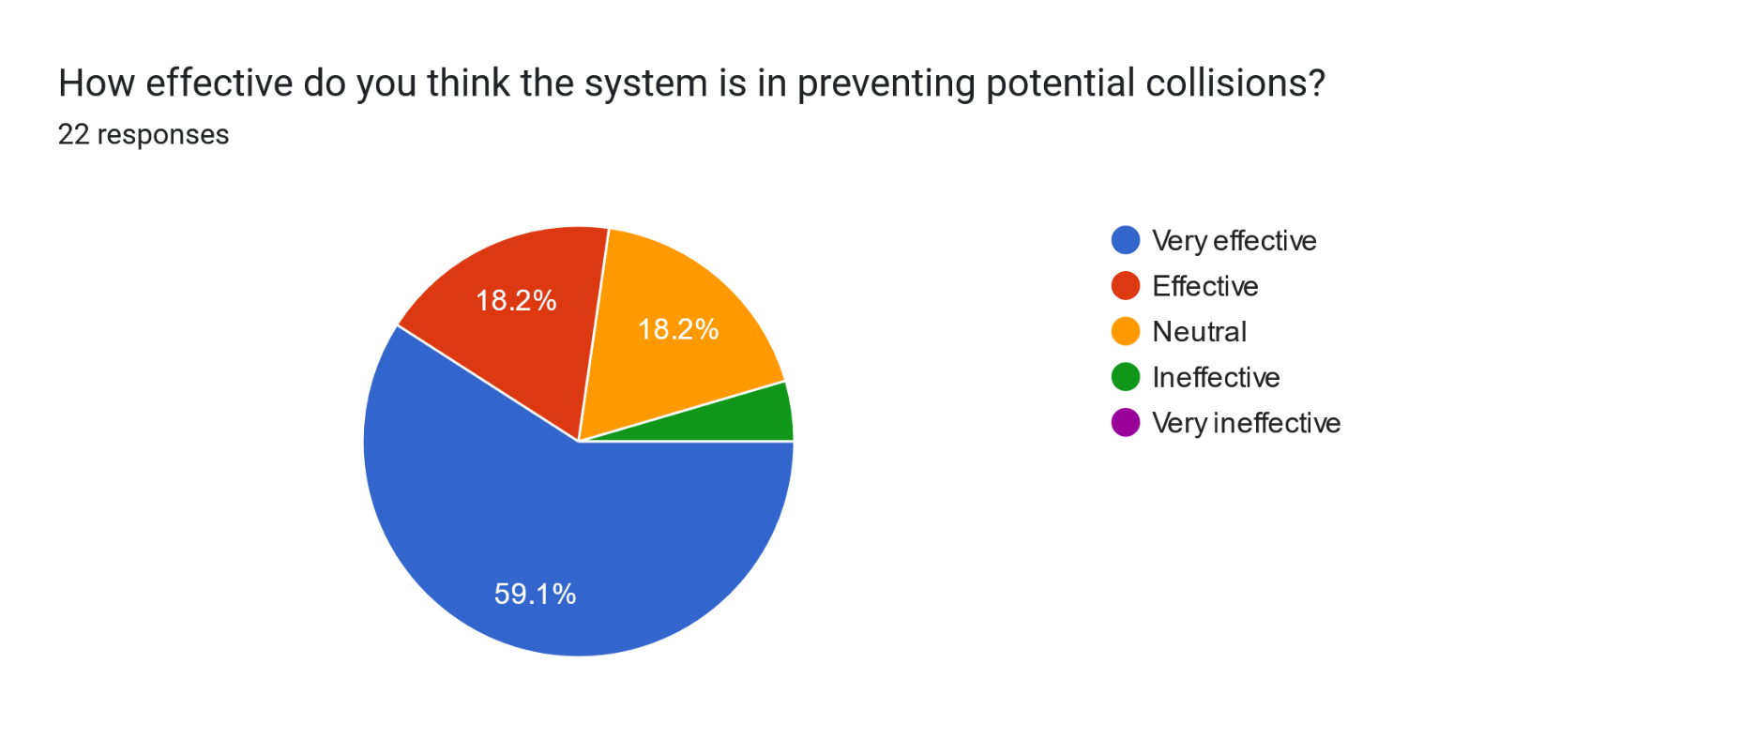

*Figure 3-1 Questionnaire Response*

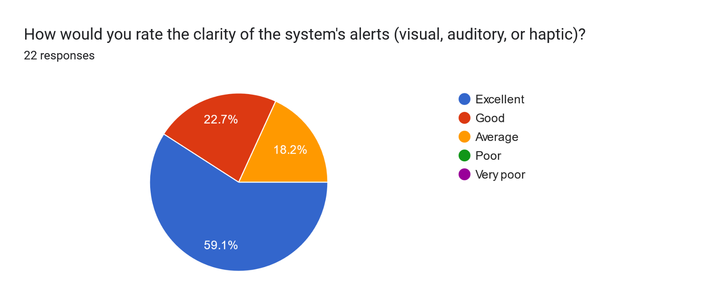

*Figure 3-2 Questionnaire Response*

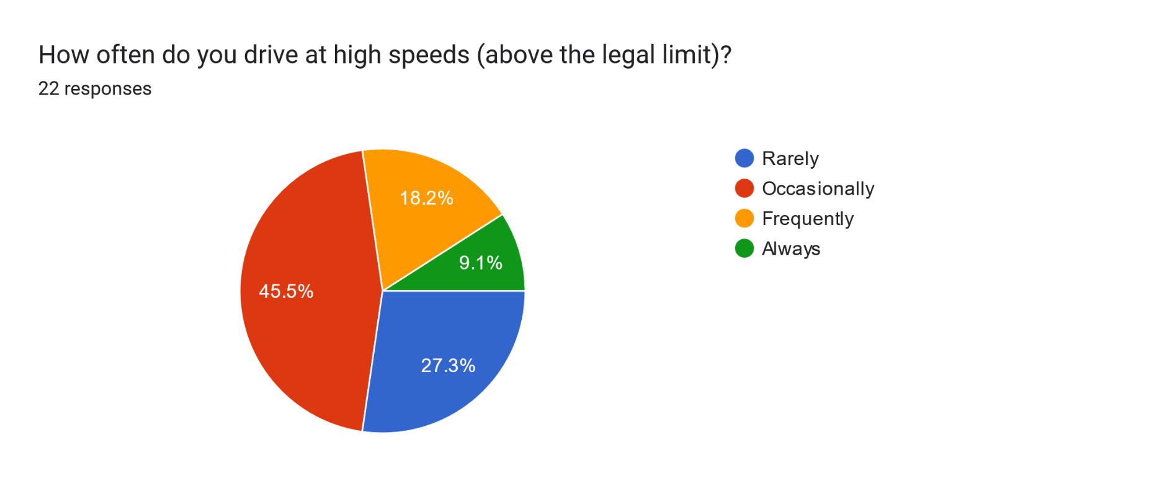

*Figure 3-3 Questionnaire Response*

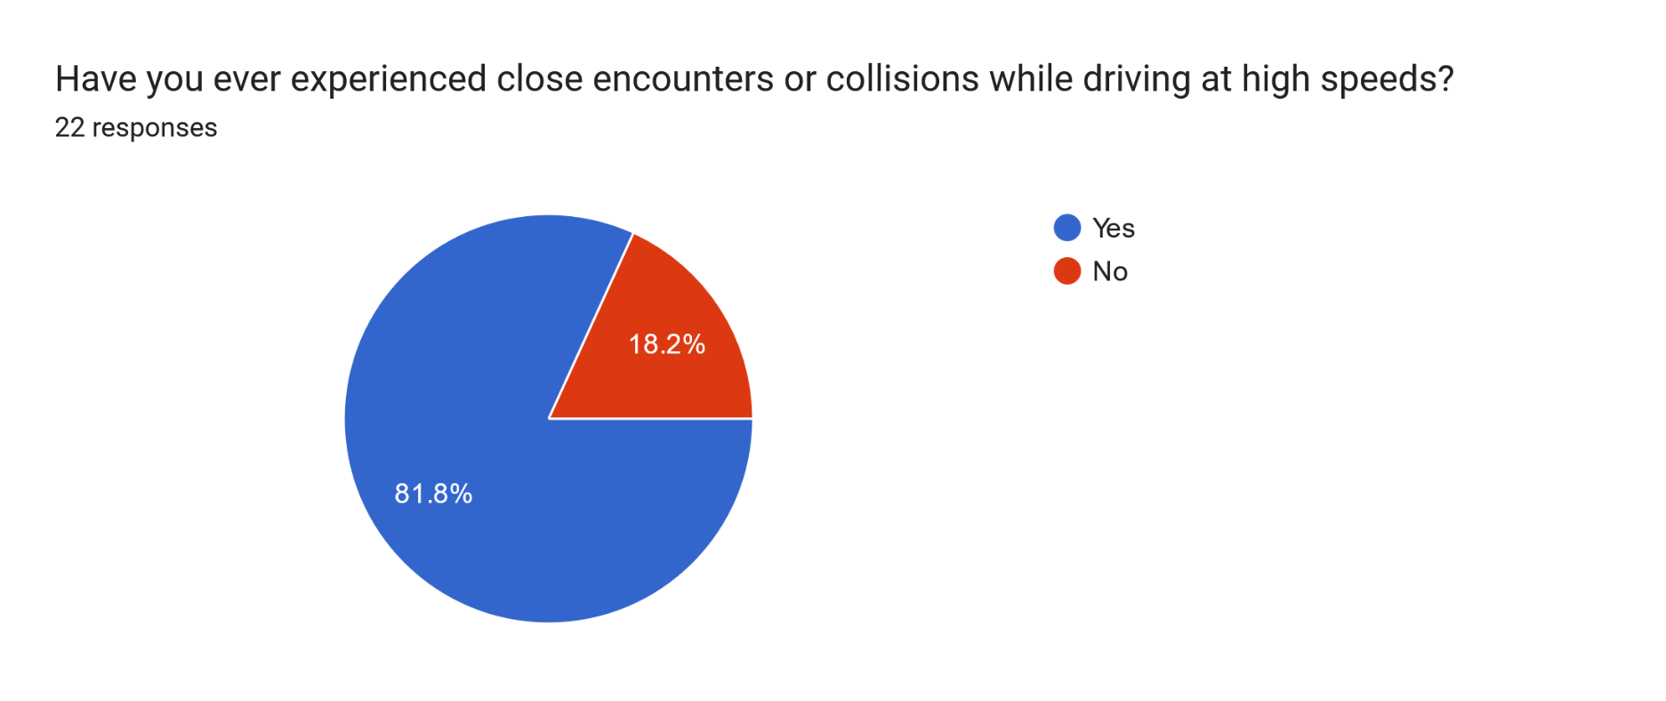

*Figure 3-4 Questionnaire Response*

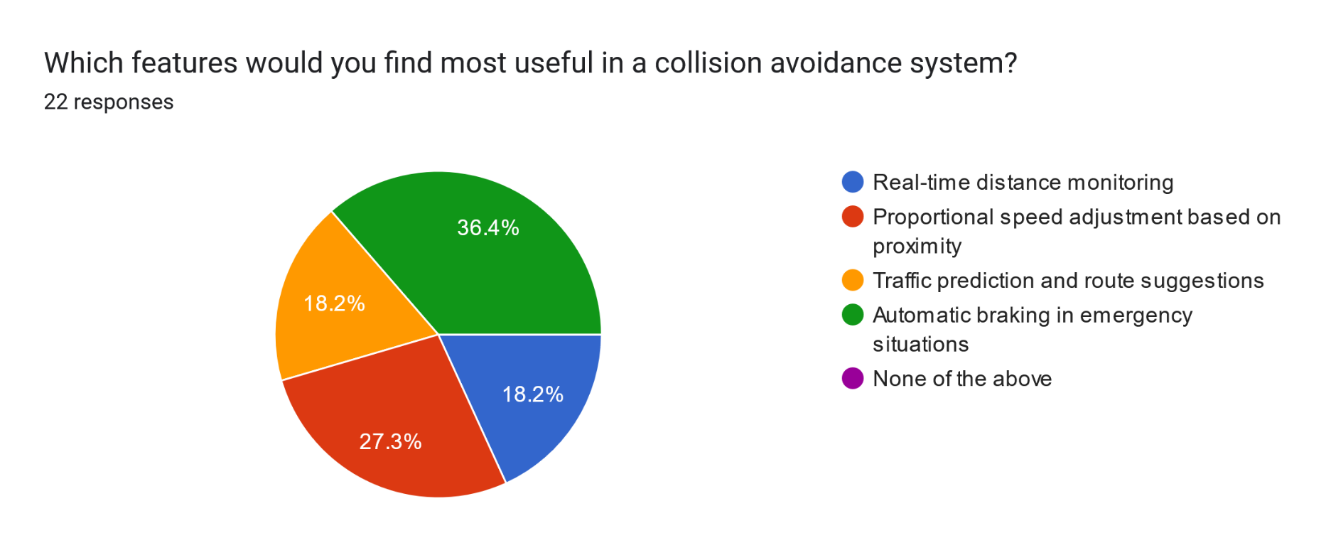

*Figure 3-5 Questionnaire Response*

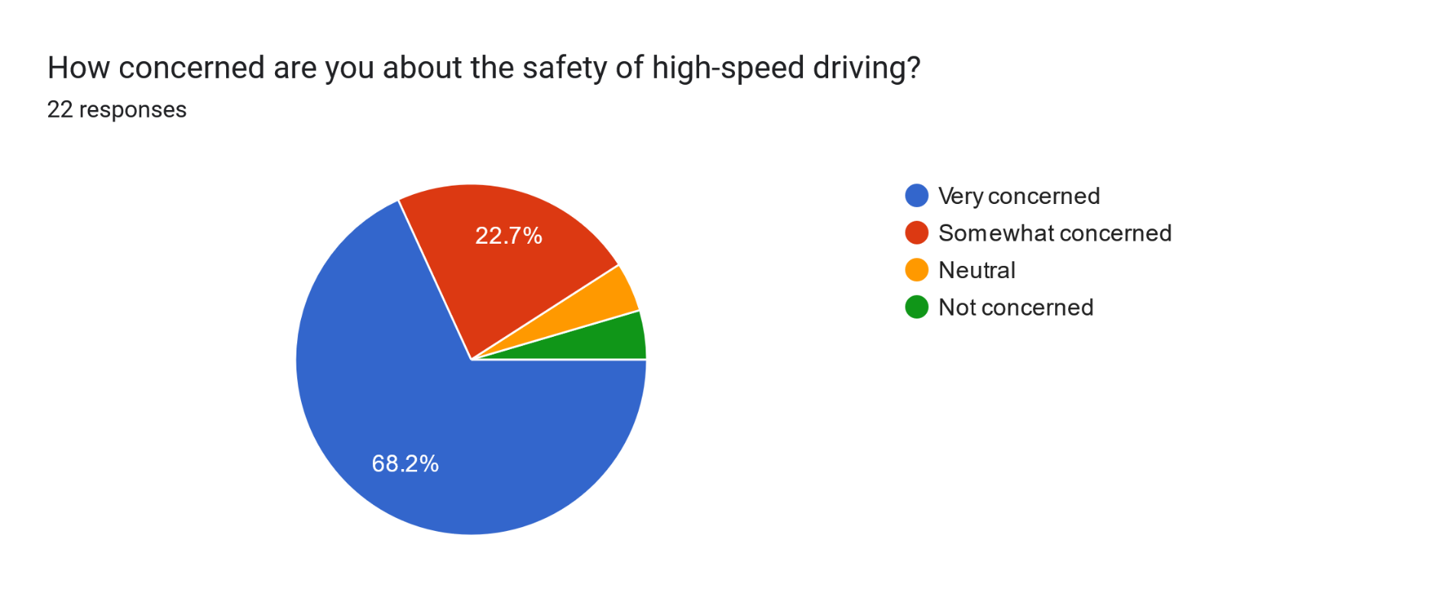

*Figure 3-6 Questionnaire Response*

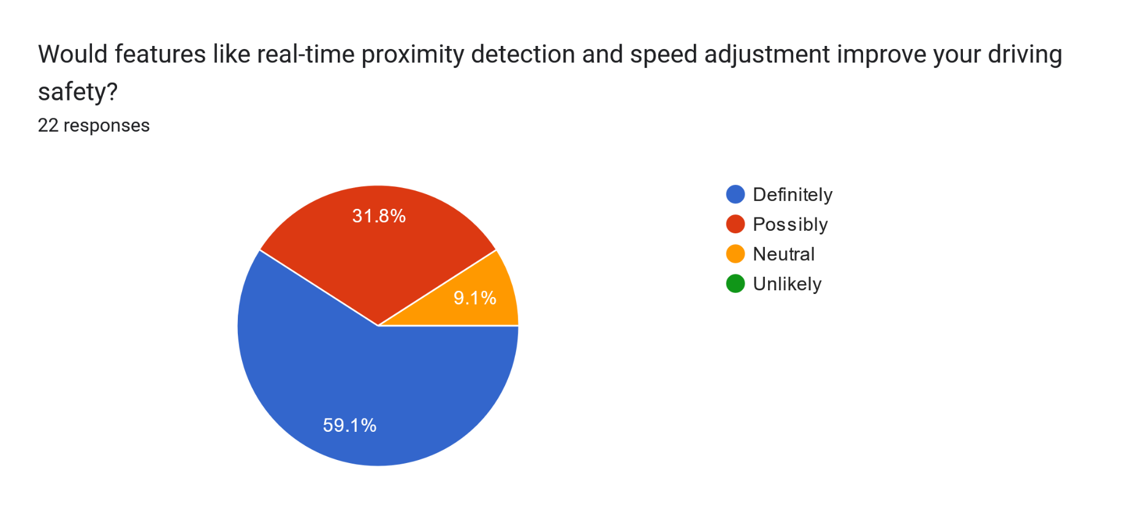

*Figure 3-7 Questionnaire Response*

*Figure 3-8 Questionnaire Response*

Long Answer Questions “Recommendations and Feedback”

**-How do you feel about a car system that adjusts speed automatically to prevent accidents?**

* **Very good**
* **Perfect**
* **Safe**
* **I feel that this can help decrease the car crashes percentage in egypt**
* **Very cool**
* **I think it's better if it alerts about high speed instead of changing it automatically**
* **it’s very useful and helpful**
* **It’s very good if it helps will save alot of lives**
* **that would be a great idea to be done**
* **helpful**
* **Something that very awesome to decrease accidents**
* **Sure this would be a great idea**

-How can proximity detection and speed control help prevent accidents when driving at high speeds?

* By controling speed or applying brakes at close proximity which may lead to accident thus preventing it.
* Very good
* It would help drivers who don't pay attention enough to the road
* it'll alert the driver and keep them focused
* Braking or giving warnings in case of any close call collision
* If you control speed and make fast response, It could control traffic and make less collision
* it cannot stop but it could reduce the damage
* By alerting the drivers
* It will help very much
  1. System Analysis
     1. Functional Requirements

**FR1: Data Acquisition:** The system shall acquire distance data from proximity sensors.

**FR2: Collision Avoidance:** The system shall detect potential collisions.

**FR3: Speed Control:** The system shall automatically adjust vehicle speed based on proximity data.

**FR4: Vehicle Tracking:** The application shall provide real-time vehicle location information.

**FR5: Traffic Analysis:** The system shall analyze traffic data to identify potential congestion.

**FR6: User Alerts:** The system shall provide users with traffic information and route guidance.

* + 1. Detailed Functional Requirements

*Table 8 Detailed Function Requirements*

|  |  |  |
| --- | --- | --- |
| Functional Requirement ID | Name | Description |
| ***DFR1.1:*** | *Data Acquisition* | *The system shall acquire distance data from proximity sensors at a minimum frequency of 10Hz.* |
| ***DFR1.2:*** | *Data Acquisition* | *The system shall filter acquired sensor data to remove noise and outliers.* |
| ***DFR2.1:*** | *Collision Avoidance* | *The system shall trigger a visual and audible warning when the distance to the nearest vehicle falls below 5 meters.* |
| ***DFR3.1:*** | *Speed Control* | *When the distance to the nearest vehicle falls below 3 meters, the system shall automatically reduce the vehicle's speed by 50%.* |
| ***DFR3.2:*** | *Speed Control* | *When the distance to the nearest vehicle falls below 1 meter, the system shall automatically bring the vehicle to a complete stop.* |
| ***DFR4.1:*** | *Vehicle Tracking* | *The application shall display vehicle locations on a map with a refresh rate of at least 1 second.* |
| ***DFR4.2:*** | *Vehicle Tracking* | *The application shall provide a user interface for zooming and panning the map.* |
| ***DFR5.1:*** | *Traffic Analysis* | *The system shall analyze historical and real-time data on vehicle density and speed.* |
| ***DFR5.2:*** | *Traffic Analysis* | *The system shall utilize machine learning algorithms to predict potential traffic jams with an accuracy of at least 80%.* |
| ***DFR6.1:*** | *User Alerts* | *The system shall provide real-time traffic updates to users via in-app notifications.* |
| ***DFR6.1:*** | *User Alerts* | *The system shall suggest alternative routes based on traffic conditions and user preferences.* |

* + 1. System Requirements

**Collision Avoidance:**

* -Detect nearby vehicles and objects using proximity sensors (ultrasonic/radar).
* -Continuously calculate distance and relative speed to nearby objects.
* -Alert the driver visually and audibly when the vehicle is too close to another object.
* -Automatically adjust vehicle speed based on the proximity of nearby objects, with incremental speed reductions proportional to the risk level.

**Radar Speed Compliance:**

* -Detect radar-enforced speed limits using cameras, GPS, or mapping data.
* -Compare the detected speed limit with the current vehicle speed.
* -Automatically reduce vehicle speed to comply with radar speed limits.

**Smart Radar Integration:**

* -Provide 360-degree object detection using high-resolution radar.
* -Detect and track multiple objects, including vehicles, pedestrians, and obstacles.
* -Operate effectively in all weather conditions (rain, fog, darkness).

**Traffic Prediction:**

* -Collect traffic data to anticipate congestion or changes in road conditions.
* -Adjust vehicle behavior proactively based on predicted traffic patterns.

**System Alerts:**

* -Notify the driver of potential collisions and speed adjustments through visual, auditory, and optional haptic feedback.

**-Driver Override:**

* -Allow the driver to temporarily disable speed adjustments via a manual override.
  + 1. User Requirements
* The system must be simple to operate, with minimal input required from the driver.App interface should be intuitive and customizable for user preferences.
* Provide unambiguous visual, auditory, and optional haptic feedback to alert drivers to potential collisions or speed adjustments.Provide visual cues (e.g., LEDs or haptic feedback) for quick device status updates.
* Allow drivers to customize alert thresholds and notification preferences to suit their driving style.
* Sensors must operate effectively under all weather conditions, including rain, fog, and snow, to ensure reliability..

• **Ease of Use:**  
The system must be simple to operate, with minimal input required from the driver.

• **Clear Alerts:**  
Provide unambiguous visual, auditory, and optional haptic feedback to alert drivers to potential collisions or speed adjustments.

• **Customization:**  
Allow drivers to customize alert thresholds and notification preferences to suit their driving style.

• **Override Capability:**  
Drivers should be able to manually disable or override the automatic speed adjustment feature when necessary.

• **Accessibility:**  
Ensure compatibility with drivers of various skill levels, including those who are less tech-savvy.//

• **Multi-Language Support:**  
Provide interface and alerts in multiple languages for accessibility in different regions.

• **Compatibility with Vehicle Models:**  
The system should integrate seamlessly with a wide range of vehicle models and makes, both new and existing.

• **User Onboarding and Guidance:**  
Include an easy onboarding process with clear instructions, tutorials, or guides for initial setup and use.

• **Aesthetic Design:**  
The interface and hardware components should have a modern and appealing design to match the vehicle's aesthetics.

• **Data Visualization:**  
Offer intuitive graphical displays for real-time sensor data, traffic predictions, and system status on the dashboard.

• **Privacy and Security:**  
Ensure user data privacy and encrypt communications to protect against unauthorized access.

• **Compatibility with Other Systems:**  
Support integration with other in-vehicle technologies, such as navigation systems and mobile applications, for enhanced functionality.

• **Responsive and Fast Performance:**  
Alerts and system actions must occur in real-time to ensure immediate response during high-speed driving.

• **Maintenance and Updates:**  
Allow easy software updates and system maintenance to ensure the system remains current and functional.

* + 1. Non – Functional Requirements

**1 Performance Requirements**

* The anti-collision system shall respond to sensor data within 100 milliseconds.
* The mobile application shall update vehicle positions every 5 seconds.

**2 Safety Requirements**

* The system shall comply with ISO 26262 standards for functional safety in automotive systems.
* The braking system shall be fail-safe and revert to manual control in case of system failure.

**3 Security Requirements**

* Data transmitted between the vehicle and the mobile application shall be encrypted using AES-256.
* The system shall implement user authentication for accessing vehicle and traffic data.

**4 Usability Requirements**

* The mobile application shall have a user-friendly interface with intuitive navigation.
* The anti-collision system shall provide clear audio and visual alerts.

* 1. 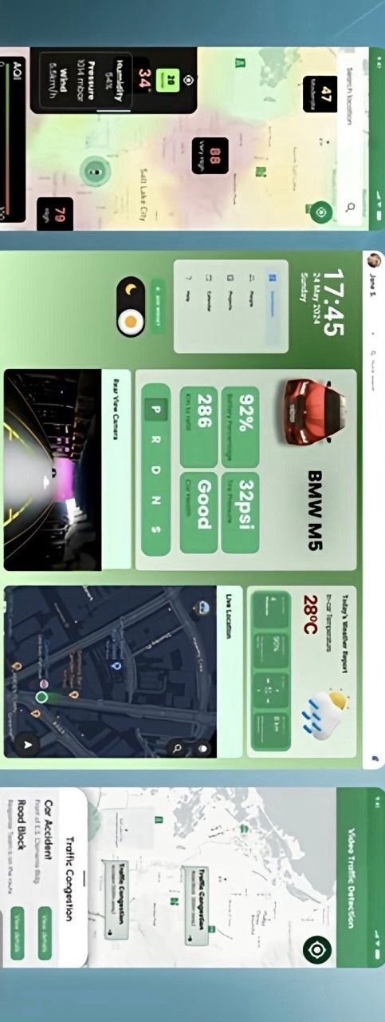System Design
     1. Proposed Model

The vehicle safety system works by using sensors (radars) and a car chip to monitor the car’s speed and surroundings. The car chip collects data and sends it to a mobile app, which analyzes traffic patterns and suggests alternative routes if it detects potential traffic jams. This helps ensure a smooth and safe driving experience.

*Figure 3-11 - Proposed Model*

Process Flow:

**Data Collection:**

* **Proximity Sensors & Radar Data**: The system continuously collects real-time distance measurements using proximity sensors (ultrasonic/radar) and radar speed limit detection.
* **Vehicle Data**: The system captures vehicle speed, direction, and relative distances from surrounding vehicles.

**Integration & Analysis:**

* **Sensor Data Integration**: The collected sensor data is processed in real-time to calculate distances and speeds.
* **AI Algorithms**: The system applies AI-driven algorithms to analyze real-time sensor data, correlating distance, speed, and risk levels.
* **Traffic Prediction**: Traffic prediction models analyze real-time and historical data to forecast traffic congestion and patterns.

**Risk Assessment & Prediction:**

* **Collision Risk Modeling**: The system evaluates proximity data to predict collision risks and determine necessary speed adjustments.
* **Radar Speed Compliance**: The system predicts and alerts drivers if they exceed radar-enforced speed limits.
* **Proportional Speed Adjustment**: Algorithms assess the level of risk and adjust the vehicle speed proportionally to maintain safe distances.

**Recommendations & Actions:**

* **Real-Time Alerts**: The system provides visual and auditory warnings when dangerous proximity or speed conditions are detected.
* **Automatic Speed Control**: If the driver does not respond, the system autonomously adjusts vehicle speed to prevent collisions.
* **Traffic Adaptation**: The system adjusts speed based on predicted traffic conditions, reducing the likelihood of congestion and collisions.
  + 1. Features

**Proximity Detection:**

* Real-time monitoring of distance to surrounding vehicles using ultrasonic and radar sensors.
* 360-degree coverage to track objects in all directions.

**Radar Speed Compliance:**

* Detects radar-enforced speed limits and ensures compliance.
* Adjusts vehicle speed automatically when exceeding speed limits.

**Collision Risk Assessment:**

* Calculates the distance and relative speed of nearby vehicles.
* Predicts collision risks based on proximity and vehicle behavior.

**Proportional Speed Adjustment:**

* Automatically reduces vehicle speed based on the proximity of surrounding vehicles.
* Adjusts speed incrementally in proportion to the level of risk.

**Real-Time Alerts:**

* Visual and auditory warnings for dangerous proximity and speed conditions.
* Increases alert urgency as risk levels increase.

**Traffic Prediction:**

* Analyzes real-time traffic conditions and historical data to forecast congestion.
* Suggests alternative routes to avoid traffic jams.

**Autonomous Action:**

* Automatically applies braking or throttle adjustments when the driver fails to respond.
* Ensures vehicle remains within safe operating parameters.

**Integration with Vehicle Systems://**

* Interfaces with braking and throttle systems via CAN bus or similar protocols.
* Seamless integration with vehicle control systems.

**Smart Radar Integration:// CHANGE CONTENT**

* High-resolution radar for accurate object tracking in varying weather conditions.
* Supports effective operation in rain, fog, and darkness.

**Driver Feedback:**

* Continuous feedback on proximity, speed, and collision risks.
* Allows manual override for speed adjustments if necessary.

**Safety & Compliance:**

* Complies with ISO 26262 standards for functional safety.
* Ensures fail-safe braking system in case of system failure.

**User-Friendly Interface:**

* Intuitive mobile app interface for monitoring system status and alerts.
* Clear audio and visual alerts for ease of use.
  + 1. Class Diagram

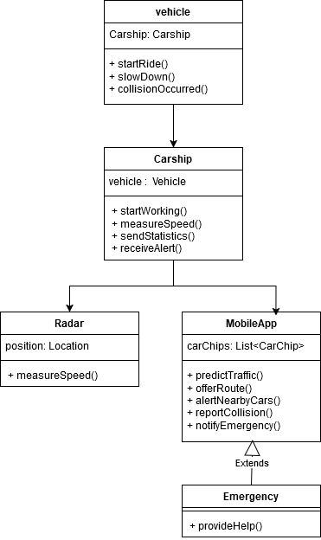

*Figure 3-12 Class Diagram*

***Vehicle:***

* ***Role:*** *A general representation of any vehicle.*
* ***Attributes:*** *None*
* ***Methods:***
  + *startRide()*
  + *slowDown()*
  + *collisionOccurred()*

***Carship:***

* ***Role:*** *A specific type of vehicle that is part of a fleet.*
* ***Attributes:***
  + *vehicle: An instance of the Vehicle class.*
* ***Methods:***
  + *startWorking()*
  + *measureSpeed()*
  + *sendStatistics()*
  + *receiveAlert()*

***Radar:***

* ***Role:*** *A device used to measure the speed of vehicles.*
* ***Attributes:***
  + *position: The current location of the radar.*
* ***Methods:***
  + *measureSpeed()*

***MobileApp:***

* ***Role:*** *An application used to interact with Carships.*
* ***Attributes:***
  + *carChips: A list of Carship objects.*
* ***Methods:***
  + *predictTraffic()*
  + *offerRoute()*
  + *alertNearbyCars()*
  + *reportCollision()*
  + *notifyEmergency()*

***Emergency:***

* ***Role:*** *A situation requiring immediate assistance.*
* ***Attributes:*** *None*
* ***Methods:***
  + *provideHelp()*

***Relationships:***

* ***Inheritance:*** *MobileApp inherits from Emergency, indicating that the MobileApp can handle emergency situations.*
* ***Association:*** *Carship is associated with Vehicle, meaning a Carship has a Vehicle component.*
* ***Aggregation:*** *MobileApp aggregates Carship objects, meaning the MobileApp manages a collection of Carships.*
* ***Dependency:*** *MobileApp depends on Radar to measure speed and predict traffic.*
  + 1. Use Cases

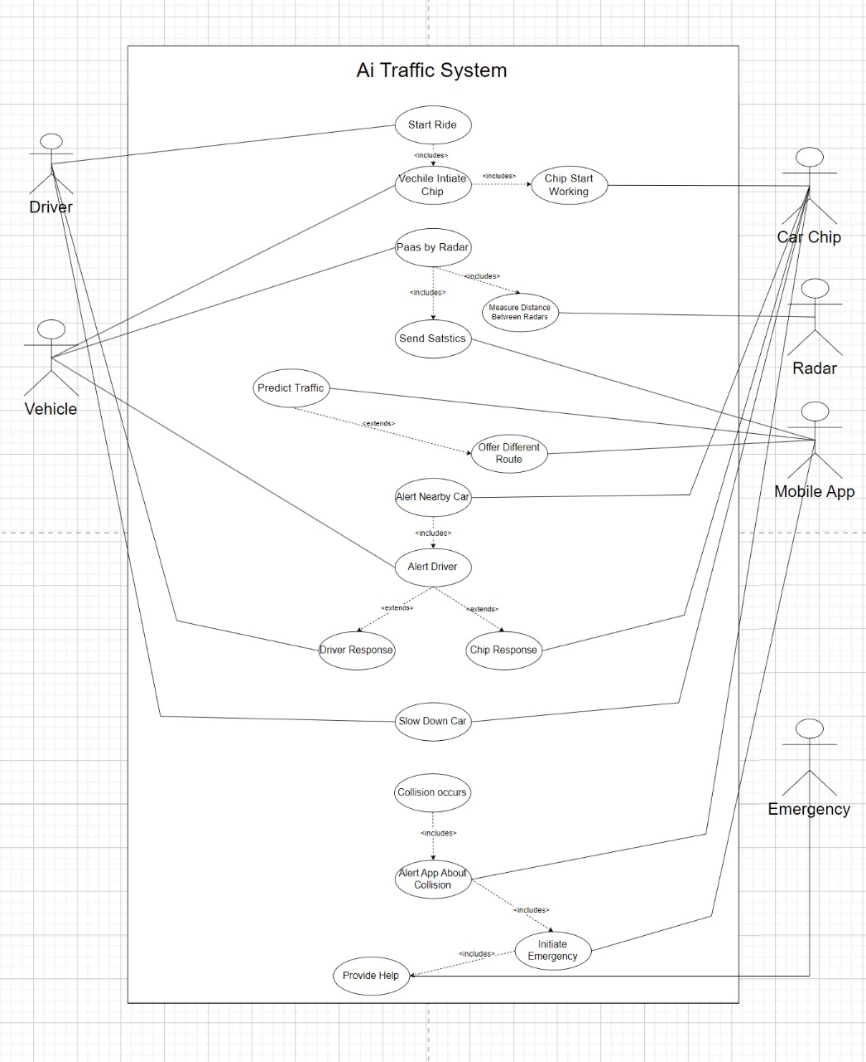

*Figure 3-13 Use case Diagram*

*Table 9 Report Use case*

|  |  |  |
| --- | --- | --- |
| Use case | Description | Core Components Involved |
| 1. Start Ride | System activation when a driver initiates a ride. | Driver, Vehicle, Mobile App |
| 2. Vehicle Initiate Chip Working | Car chip activation for communication with the system. | Vehicle, Car Chip |
| 3. Pass by Radar | Measurement of vehicle position and distance between vehicles as they pass by radar points | Vehicle, Radar |
| **4. Send Statistics** | Collection and transmission of traffic flow and vehicle position data. | Radar, Car Chip, Mobile App |
| **5. Predict Traffic** | System analyzes data to predict traffic congestion or delays. | System, Car Chip, Radar |
| **6. Offer Different Route** | Suggesting alternative routes based on traffic predictions. | System, Mobile App |
| **7. Alert Nearby Car** | Triggering alerts to nearby vehicles in case of detected collisions. | Radar, Car Chip, Vehicle |
| **8. Alert Driver** | Driver notification of potential hazards or traffic conditions. | Mobile App, Car Chip, Vehicle |
| **9. Driver Response** | Driver acknowledges or responds to alerts, such as slowing down. | Mobile App, Car Chip, Vehicle |
| **10. Chip Response** | Car chip responds to alerts, adjusting vehicle behavior, such as slowing down. | Car Chip, Vehicle |
| **11. Slow Down Car** | Vehicle instructed by the system to slow down to avoid a collision. | Car Chip, Vehicle, System |
| **12. Collision Occurs** | Emergency response triggered in case of collision. | Car Chip, Mobile App, Emergency Services |
| **13. Alert App About Collision** | Mobile app notified of collision to alert driver and others. | Mobile App, Emergency Services |
| **14. Initiate Emergency** | Emergency services dispatched to the collision scene. | Emergency Services |
| **15. Provide Help** | Assistance provided to those involved in the collision. | Emergency Services |

*Table 10 Recommendation Use Case*

|  |  |  |
| --- | --- | --- |
| Recommendation Use Case | Description | Core Components Involved |
| **1. Improve Traffic Flow** | Enhance radar coverage and accuracy to ensure precise vehicle position tracking. | Radar, Car Chip, System |
| **2. Real-Time Data Integration** | Implement better data synchronization between car chips, radars, and mobile apps for accurate predictions. | Car Chip, Radar, Mobile App, System |
| **3. Advanced Prediction Models** | Use machine learning models to predict traffic congestion more accurately. | System, Car Chip, Radar, Mobile App |
| **4. Adaptive Routing Algorithms** | Develop more intelligent routing algorithms that offer dynamic, real-time route suggestions. | System, Mobile App |
| **5. Improved Alert Systems** | Enhance the alert system to provide more timely and actionable warnings to drivers and nearby vehicles. | Radar, Car Chip, Mobile App |
| **6. Increase Driver Engagement** | Provide interactive features within the mobile app to improve driver responses to alerts. | Mobile App, Car Chip, Vehicle |
| **7. Vehicle Autonomy Enhancements** | Allow car chips to automatically adjust vehicle behavior in real-time, reducing driver intervention. | Car Chip, Vehicle, System |
| **8. Emergency Response Optimization** | Ensure faster and more efficient emergency services deployment in case of collisions. | Radar, Car Chip, Mobile App, Emergency Services |
| **9. Enhanced Mobile App Features** | Add more user-friendly features, such as traffic updates, route recommendations, and incident reporting. | Mobile App, System |
| **10. Data Security and Privacy Measures** | Implement stricter privacy policies to protect sensitive data collected by the system. | Car Chip, Radar, Mobile App, System |

ACTIVITY DIAGRAM

* + 1. Sequence Diagrams

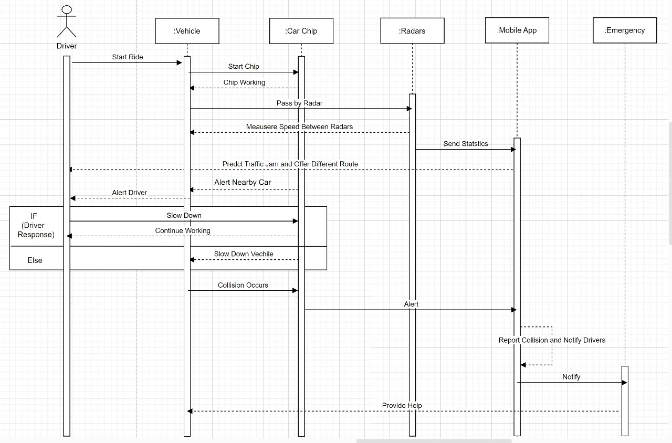

*Figure 3-14 General Sequence Diagram*

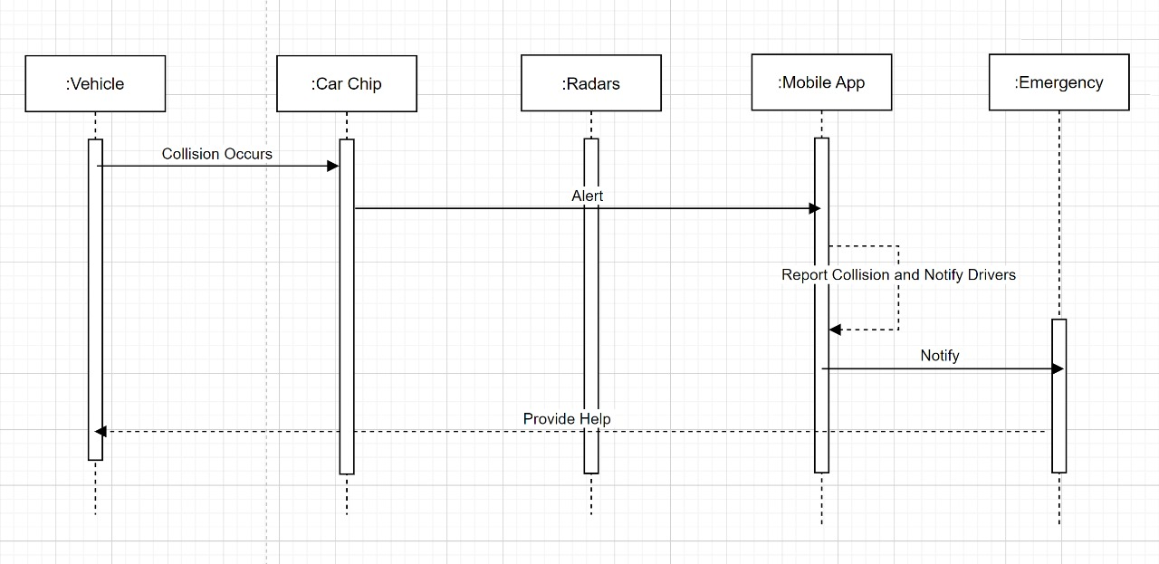

*Figure 3-15 Collision Sequence Diagram*

This diagram shows what happens when a car gets into an accident. The vehicle safety system is designed to detect the crash quickly and notify the necessary people so they can respond as soon as possible.

When a collision happens, sensors in the car, like radars, detect the impact. The car chip, a small device inside the vehicle, notices the crash and immediately sends an alert to a mobile app. The app then sends the alert to emergency services, like ambulances or the police, letting them know where the accident happened. At the same time, the app warns nearby drivers so they can slow down and avoid the area.

Emergency services receive this information, helping ensure they arrive at the scene quickly to assist those involved. The goal is to minimize delays and make sure help reaches the scene as fast as possible, keeping everyone safer.

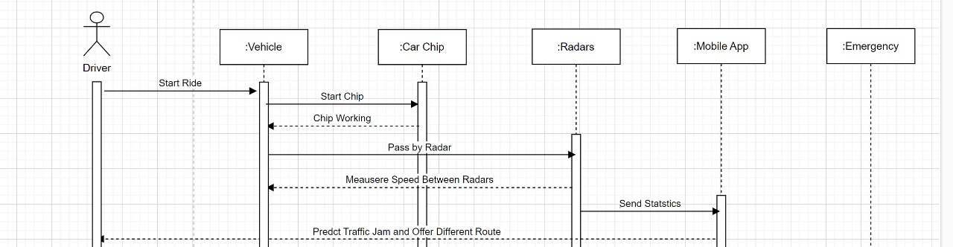

*Figure 3-16 route prediction Sequence Diagram*

This diagram shows how the vehicle safety system works during a typical drive, when everything is running smoothly. It focuses on the steps and interactions between the various components to keep the vehicle safe.

The driver starts the journey by turning on the car. As soon as the car starts, the car chip, a small device inside, gets activated and begins communicating with other parts of the system. The car chip keeps an eye on things like the car’s speed, the road conditions, and nearby vehicles.

Meanwhile, radars placed around the car are constantly scanning the area. When the car passes a radar, it gets activated, and the radar checks the car’s speed and other details. The radar then sends that information to the car chip, which processes the data.

The car chip sends all the collected information like speed data to the mobile app. The app uses this data to analyze traffic patterns and predict situations like traffic jams. If it sees a potential backup or slowdown ahead, the app suggests a different route to avoid the congestion.

This whole process helps the system keep track of things, ensure everything is safe, and provide useful information to the driver to make their journey smoother and more efficient.

*Figure 3-17 Alert Nearby Car Sequence Diagram*

The system is designed to keep drivers safe by alerting them to potential hazards while driving. Inside the car, a smart device called the Car Chip monitors the environment and driving conditions. When it detects something dangerous, like an obstacle or bad weather, it sends an alert to the driver. The driver can then decide how to respond: either slow down if they agree with the alert or keep driving if they think there’s no real danger. If the driver chooses to slow down, the Car Chip helps by adjusting the car’s speed. If the driver decides to continue, the system doesn’t interfere but keeps monitoring the situation. The system uses a simple decision-making process to handle these responses, ensuring the driver stays in control while providing support when needed.

* + 1. Architectural Design

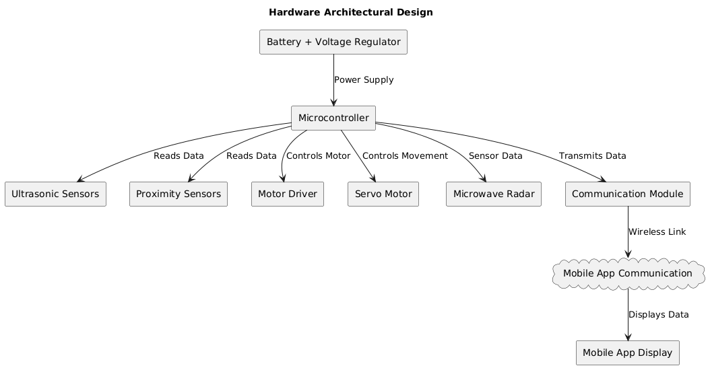*Figure 3-20 Hardware Architecture Diagram*

1. ***Battery + Voltage Regulator****:*
   * ***Battery****: Provides power to the entire system.*
   * ***Voltage Regulator****: Makes sure the correct voltage is supplied to the components.*
2. ***Microcontroller****:*
   * *The "brain" of the system that controls all operations. It takes data from sensors, processes it, and controls other components like motors.*
3. ***Ultrasonic Sensors****:*
   * *These sensors measure distance by sending sound waves. They help the system "see" obstacles or measure how far something is.*
4. ***Proximity Sensors****:*
   * *These sensors detect nearby objects or movements. They're used to know if something is close to the system.*
5. ***Motor Driver****:*
   * *Controls the motors based on signals from the microcontroller. It regulates the movement of the motors.*
6. ***Servo Motor****:*
   * *A type of motor that can move to a specific position. It is used to perform precise movements based on commands from the microcontroller.*
7. ***Microwave Radar****:*
   * *Uses microwave signals to detect objects, measure distances, or scan areas for movement. This sensor helps in detecting things over a wider range.*
8. ***Communication Module****:*
   * *Allows the system to communicate wirelessly, sending data to the mobile app (like over Wi-Fi or Bluetooth).*
9. ***Mobile App Communication****:*
   * *The mobile app connects to the system wirelessly through the communication module.*
10. ***Mobile App Display****:*

* *The mobile app shows information or data gathered from the system, like sensor readings or control options.*

***Data Flow:***

* ***Battery*** *powers the system and provides electricity.*
* *The* ***Microcontroller*** *processes data from the* ***Ultrasonic*** *and* ***Proximity Sensors****, controls the* ***MotorDriver*** *and* ***ServoMotor****, receives data from the* ***Radar****, and sends data to the* ***Communication Module****.*
* *The* ***Communication Module*** *sends data wirelessly to the* ***Mobile App****, which then displays the data on the* ***Mobile App Display****.*
  1. Summary

This chapter presents a detailed blueprint for developing an Adaptive Collision Avoidance System (ACAS), aiming to enhance driver safety in high-speed driving conditions. By employing a structured system analysis approach, the project focuses on integrating advanced technologies such as proximity sensors, smart radar, and real-time traffic prediction algorithms. The system is designed to dynamically adjust vehicle speed based on real-time data, improving situational awareness and reducing collision risks. Through careful consideration of both functional and non-functional requirements, the ACAS ensures usability, security, and scalability. The integration of intelligent systems and signal processing algorithms plays a crucial role in making the system effective under varying driving conditions.

*Chapter Four*

## Implementation

#### Introduction

Chapter Four explores the design and development of the AI-powered traffic management system, focusing on its key components and technological considerations. The chapter begins by underscoring the importance of leveraging real-time and historical GPS data for predictive analytics, aiming to forecast traffic patterns, optimize routes, and prevent congestion. It then details the development environment, integrating both hardware and software components, including advanced sensors for proximity detection, GPS modules, and AI frameworks such as TensorFlow and PyTorch for traffic prediction algorithms. Additionally, the chapter emphasizes the use of Figma for prototyping, ensuring the creation of intuitive, interactive, and user-friendly interfaces for the companion app. Together, these elements establish a robust foundation for an intelligent, responsive, and user-centric traffic management solution.

.

#### Data Sets

The **AI Traffic System** leverages comprehensive datasets to enhance accident detection, emergency response, and overall traffic management. These datasets provide the foundation for real-time monitoring, safety, and system improvements:

1. • **Accident Detection Data**:

* Impact Sensors: Detect sudden deceleration, collision forces, or airbag deployment.
* Vehicle Status: Real-time monitoring of brake, steering, and other critical system statuses during an incident.

1. • **Emergency Response Data**:

* GPS location and accident timestamps are instantly relayed to the companion app.
* Driver and vehicle identification data are securely shared with emergency services.

1. • **Incident History**:

* Records of previous accidents, including location, time, and severity, for analysis and improving response times.

1. • **User Feedback**:

* Post-incident user reports collected to refine detection algorithms and enhance system reliability.

These datasets provide a strong basis for accident detection, immediate alerts, and long-term system improvements.

#### Development Environment

The **AI Traffic Management System** is built using a robust development environment that integrates software, hardware, and design tools:

Software Development

Mobile Application Framework:

* **Flutter**: For developing the cross-platform app that provides emergency alerts and integrates with vehicle systems.
* **Integration** with Firebase:
  + • Real-time database : for logging accidents and sharing updates with emergency services.
  + • Authentication : for secure access to critical data.
  + • Push notifications : to alert the user and emergency responders immediately..
* **Backend Framework:**
  + Firebase Functions for serverless logic.
  + Dart for logic implementation and Firebase SDK integration. AI Integration:
* • **TensorFlow Lite or Edge AI SDKs**: Powers real-ti
* me predictive analytics and integrates AI models into the app.
* • **Model Training**: Uses Python for training predictive analytics models before deploying to TensorFlow Lite.

IDE and Tools:

* Android Studio or VS Code with Flutter/Dart plugins.
* Firebase Console for managing backend services.
* GitHub/GitLab for version control and collaboration.

Hardware

**• Core Components:**

* **Arduino**: Serves as the main microcontroller for processing sensor data and managing system logic.
* **Ultrasonic Sensors**: Measure distances to detect obstacles and ensure safe proximity between vehicles.
* **Proximity Sensors**: Detect nearby objects and enhance collision avoidance functionality.

**• Prototyping Tools:**

* **Jumpers and Breadboard:** Facilitate prototyping and connections between components during development**.**

**• Vehicle Components:**

* **Motor Driver:** Controls the movement and speed of the car's motors.
* **Servo Motor:** Handles precise angular movement for steering or other adjustments.
* Additional electronic components for vehicle integration.

**• Radar Module:**

* **Microwave Radar (e.g., RCWL-0516):** Provides real-time motion detection and object sensing capabilities.

**• Communication Module:**

* **NRF24L01 or ESP8266:** Enables wireless data transmission through Wi-Fi or RF, facilitating connectivity with the mobile app.

**• Power Supply:**

* **Rechargeable Li-ion Battery:** Ensures reliable energy delivery with an efficient design for prolonged use.
* **Power Management IC:** Optimizes energy consumption and enhances battery life.

Database

1. Firebase Realtime Database:
   * Storing live traffic and accident data, syncing information across devices..
2. Real-Time Collaboration:
   * Foster teamwork between designers, developers, and stakeholders with shared access for iterative feedback..
3. Design Consistency:
   * Utilize Flutter-compatible components to ensure seamless translation from design to development.

Prototyping with Figma

Interactive Prototypes

* Create clickable wireframes to simulate user flows and app interactions.
* Visualize the user interface for seamless navigation and usability testing. Real-Time Collaboration
* Enable team collaboration between designers, developers, and stakeholders.
* Share designs for feedback and iterative improvements. Design Consistency
* Utilize Flutter-compatible design components for a smooth transition to development.
* Ensure consistency in UI/UX across all screens and features.

#### Application Prototype

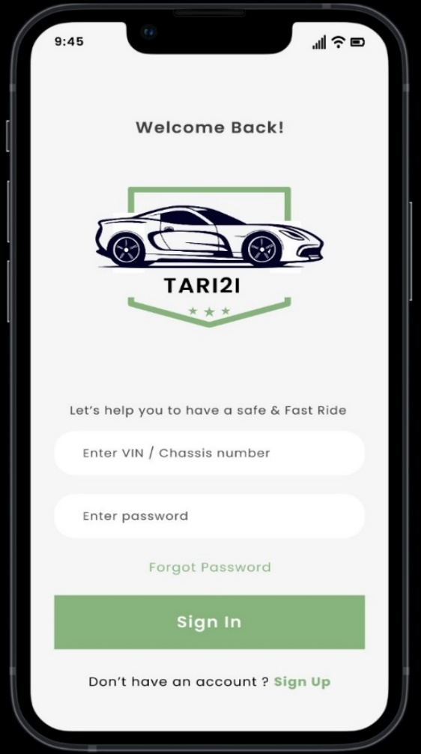

#### Conclusion

In conclusion, Chapter Four provides a comprehensive overview of the technical and operational constraints involved in the AI traffic system integrates advanced hardware and software components to provide a seamless and efficient traffic management solution. By leveraging real-time data from GPS, sensors, and machine learning algorithms, the system predicts traffic patterns, prevents accidents, and optimizes routes for better travel experiences. The mobile app enhances user engagement by offering real-time alerts and emergency notifications.

By addressing key development challenges and utilizing innovative technologies, this system sets the foundation for a safer, more efficient road network that enhances both driver safety and traffic flow

*Chapter 5*

1. Conclusion and Future Work
   1. Conclusion

This project demonstrates the significant potential of integrating artificial intelligence (AI) with automotive technologies to improve road safety and traffic efficiency. Traditional traffic management systems have often struggled to address real-time traffic prediction, accident prevention, and efficient route planning. By integrating AI-powered systems, real-time data collection, and predictive analytics, this project offers a solution that can proactively manage traffic and reduce accidents.

The proposed AI traffic system combines advanced vehicle sensors, a mobile application, and machine learning algorithms to create a comprehensive, real-time traffic management solution. Features like automatic accident detection, radar avoidance, and traffic prediction empower drivers to make informed decisions, enhancing road safety and reducing travel time. The integration of data from GPS and sensors, along with the ability to alert emergency services, ensures rapid response in the event of an accident.

Through careful analysis of market trends and a comparative review of existing solutions, this system's unique value proposition—optimizing traffic flow while maintaining safety—was established. Moreover, adherence to data privacy standards and ensuring smooth hardware-software integration further reinforce the system’s reliability and user trust.

The technical implementation of the system, including the use of AI for predictive analytics and real-time processing, provides a robust foundation for further development. Innovations like cloud-based infrastructure for data analysis and machine learning model optimization are central to making this system both adaptable and scalable for diverse environments. Despite challenges such as sensor accuracy and real-time data processing, these were addressed through rigorous testing and thoughtful design.

In conclusion, this project bridges the gap between traditional traffic management and the emerging need for AI-driven, predictive traffic systems. By improving road safety, reducing congestion, and ensuring faster emergency response, the system represents a step toward smarter, more efficient traffic networks and safer driving experiences.

#### Future Work

The scope for future work encompasses various innovative improvements aimed at enhancing the system’s capabilities, functionality, and overall user experience:

1. Improved Predictive Models :

Future work will focus on refining the machine learning models used to predict traffic patterns and accident risk. Advanced data preprocessing techniques such as noise reduction and feature engineering will be employed to improve model accuracy and responsiveness.

* + New data sources, including weather patterns and real-time traffic updates, will be integrated to provide more accurate traffic predictions.

1. Hardware Enhancements :
   * Future iterations will involve further development of the chip embedded in vehicles. The next phase will focus on improving sensor capabilities to enhance distance measurement accuracy and speed detection.
   * Manufacturing improvements will be made to reduce the cost and increase the scalability of the hardware, ensuring accessibility to a broader range of vehicles.
2. Mobile App Development and Features :
   * A dedicated mobile app will be enhanced to provide users with an intuitive interface for managing their traffic routes, receiving real-time alerts, and interacting with the system.
     + **Front-End Development**: Improved user interface design to accommodate diverse user needs, incorporating accessibility features and multilingual support.
     + **Back-End Development:** A secure and scalable infrastructure for real-time data processing, alerts, and user interaction management.
     + **Additional Features**: Integration with third-party apps (such as navigation systems) and adding new features like driver behavior analysis and environmental hazard alerts will be prioritized.
3. Expanded Integration and Connectivity
   * Future work will explore the integration of the system with other transportation technologies, such as smart city infrastructure, vehicle-to-vehicle (V2V) communication, and autonomous driving systems.
   * Improved connectivity options, including the integration of 5G networks for faster data transfer and real-time communication, will be explored to ensure continuous and seamless operation..
4. Continuous Learning and Model Adaptation

A mechanism for continuous learning will be implemented, allowing the system to adapt to evolving traffic patterns, road changes, and user behavior over time. This will ensure the system remains accurate and responsive to new challenges and developments in traffic conditions.

1. Exploring Emerging Technologies
   * Future versions of the system will explore incorporating additional features like augmented reality (AR) for visualizing traffic data and enhanced user interaction, as well as blockchain technology for secure, decentralized data sharing.
2. User Training and Education
   * As the system becomes more advanced, user education and training resources will be created to assist drivers in understanding and maximizing the system’s capabilities. Special attention will be given to older drivers and those less familiar with technology, ensuring the system is accessible to a wide audience.

### References

1. <https://censusinfo.capmas.gov.eg/metadata-en-v4.2/index.php/catalog/676/related_materials>

# الملخص

في عصر النقل الحديث، تظل سلامة الطرق من أهم القضايا، خاصة في ظروف القيادة عالية السرعة حيث يكون وقت الاستجابة محدودًا والهامش للخطأ ضئيلًا. تعتبر حوادث الطرق الناتجة عن التصادمات من أبرز أسباب الوفيات والإصابات على مستوى العالم، وغالبًا ما تنتج عن عجز السائقين في الاستجابة بسرعة للتغيرات المفاجئة في ديناميكيات المرور.

تم تصميم نظام تجنب التصادم التكيفي للقيادة عالية السرعة لمعالجة هذه التحديات من خلال دمج التقنيات المتقدمة، بما في ذلك أجهزة استشعار القرب، وأنظمة الرادار الذكية، وخوارزميات التنبؤ بحركة المرور. يقوم النظام بمراقبة محيط المركبة باستمرار، ويقوم بتقييم المخاطر المحتملة، وتقديم تنبيهات فورية للسائق. إذا فشل السائق في اتخاذ إجراء تصحيحي، يقوم النظام بتعديل سرعة المركبة تلقائيًا بما يتناسب مع مستوى الخطر، مما يقلل بشكل كبير من خطر التصادم.

ما يميز هذا النظام عن الحلول الحالية هو دمج مجموعة من الميزات المبتكرة، مثل التغطية بالرادار بزاوية 360 درجة، التنبؤ بحركة المرور في الوقت الفعلي، وتعديل السرعة بشكل ديناميكي استنادًا إلى قرب المركبة وحدود السرعة الخارجية التي تفرضها أجهزة الرادار على الطرق. من خلال دمج هذه القدرات، يعزز النظام وعي السائق وفي الوقت ذاته يتدخل بشكل فعال لتعزيز سلامة الطرق.

يسعى هذا المشروع إلى تقدم تقنيات السلامة في صناعة السيارات من خلال تقديم حل قوي وذكي مصمم خصيصًا للسيناريوهات عالية السرعة. من خلال ذلك، يهدف إلى تقليل الحوادث وتعزيز تجارب القيادة الآمنة لجميع مستخدمي الطريق.



### الأكاديمية العربية للعلوم والتكنولوجيا والنقل البحري

**كلية الحاسبات وتكنولوجيا المعلومات – القاهرة**

**علوم الحساب**

مشروع التخرج للبكالوريوس

نظام تجنب التصادم التكيفي للقيادة عالية السرعة

مقدمة من:

|  |  |
| --- | --- |
| روان عماد  ساندي جمال | حسن وليد  جون ممدوح  عمار مصباح |
|  |  |
|  |  |

تحت إشراف:

|  |
| --- |
| د . مصطفي عبدالعظيم |

يناير - ٢٠٢٥